

**USER MANUAL SIGN-OFF**

**Authorization Memorandum**

This form is to sign-off completion of the Design Phase for **CAMPUS MANAGEMENT SOFTWARE AT WORLD SKILL CENTER (WSC).**

World Skill Centre (WSC) acknowledges receipt of the deliverables as part of the Design Phase through the submission of this document.

|  |  |
| --- | --- |
| **MODULE NAME** | **HOSTEL** |
| **MODULE OWNER** |  |

**WSC AUTHORITY NAME AND SIGNATURE**

**SOUL AUTHORITY NAME AND SIGNATURE**

 



**Sustainable Outreach And Universal**

**Leadership (SOUL) Limited**

**User Manual**

Of

**HOSTEL Module**

For Implementation of

**Campus Management Software**

at

**World Skill Center (WSC)**

**Confidentiality**

This document is a strictly confidential communication to and solely for the use of the recipient and may not be reproduced or circulated without SOUL Ltd’s prior written consent. If you are not the intended recipient, you may not disclose or use the information in this documentation in any way

**Document Control History**

|  |  |  |  |  |
| --- | --- | --- | --- | --- |
| **Date** | **Version No.** | **Created By** | **Affected Sections** | **Reviewed By** |
|  |  |  |  | Sharmistha Panda |

Table Of Contents

USER MANUAL SIGN-OFF 1

Authorization Memorandum 1

1 Introduction 5

1.1 Background 5

1.2 Scope and Purpose of the document 5

2 General Procedures 6

2.1 General Procedure for Save Screen 6

2.2 General Procedure for Submitted Document 15

3 Master Screens 19

3.1 Hostel Masters 19

3.2 Room Masters 20

3.3 Hostel Type 22

3.4 Room Type 23

3.5 Room Description 24

3.6 Employee Hostel Allotment 25

4 Hostel Enrollment & Process 28

4.1 Student Hostel Admission 28

4.2 Student Medical History 29

4.3 Student Leave Process 30

4.4 Material Distribution 32

4.5 Material Distribution Master 33

4.6 Room Allotment 34

4.7 Room De-Allotment 36

4.8 Room Change 37

4.9 Student Mortality Record 39

4.10 Long Leave 40

4.11 Inter or Intra Hostel Change 42

4.12 Hostel Attendance 43

4.13 Hostel Attendance Tool 44

4.14 Hostel Clearance 45

# Introduction

The World Skill Center (WSC) is a premier advanced skill training institute established by the Government of Odisha, Skill Development and Technical Education Department, through the Odisha Skill Development Authority (OSDA). The WSC will impart advanced skill training in eight trades from engineering and service sectors. WSC caters primarily to induct the best talent from ITIs and Polytechnics and training them to become globally employable in emerging areas such as "Industry 4.0". WSC is housed in a state-of-the-art, 18-storey, air-conditioned building with nearly half a million square feet of space in the heart of capital city of Bhubaneswar.

With the implementation of campus management software for WSC the goal is to streamline the operations and functions of the campus by integrating various processes, such as admissions, course registration, academic progress tracking, and financial management, HRMS, Procurement and Inventory management, etc into a unified system. The implementation also aims at providing a user-friendly interface for all stakeholders, making it easier for them to access the necessary information and complete their tasks with ease. The modules to be covered during the implementation of the software include:

|  |  |
| --- | --- |
| Students Management Modules | Infrastructure Management |
| Academic System | Finance and Accounting System |
| Procurement & Inventory Management | Training and Placement |
| Human Resources Management System | Application Integration |

## Background

The Web Based Campus Management Application at World Skill Centre (WSC) application is required by WSC for the smooth operation of all departments / support functions with on-line delivery of services to all stakeholders.

The project aims to create a mechanism to provide the basis for evolution of an IT enabled state of the art workflow automation system in a planned manner.

## Scope and Purpose of the document

A user manual is a document provided to a user that helps in using a particular system, product or service seamlessly. It is also known as an instruction manual or a user guide. Such documents cover detailed information around operations, standards & guidelines, [troubleshooting guides](https://document360.com/blog/troubleshooting-guide/" \t "https://document360.com/blog/creating-a-user-manual/_blank), functionalities & more.

This document covers all the aspects of HRMS module. This module helps in organizing the entire HRMS setup such as Masters,Employee Lifecycle,Leave Management,Shift Management,Appraisal and Recruitment process.

The scope of HOSTEL Module:

# General Procedures

## General Procedure for Save Screen

**Create New document**

Login on to the system

Go to the required workspace

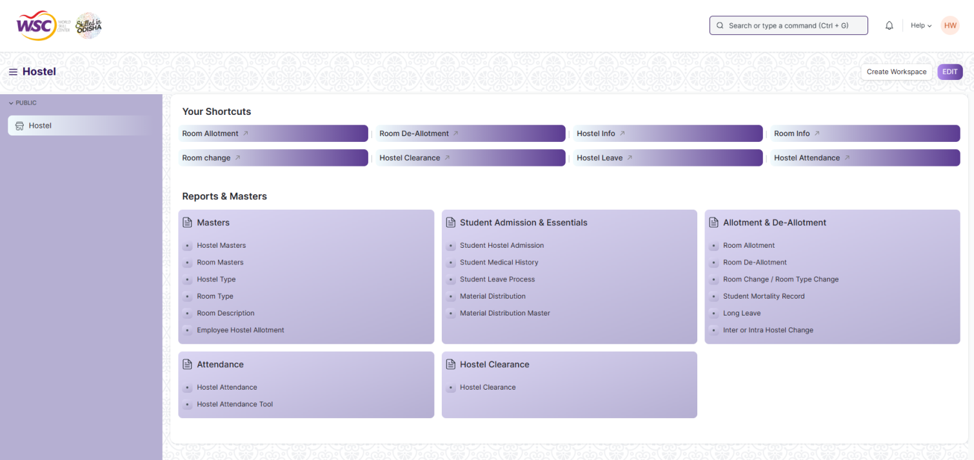

* Go to the required screen.
* Click on the ***“+Add Screen Name”*** button in the right corner of the screen.

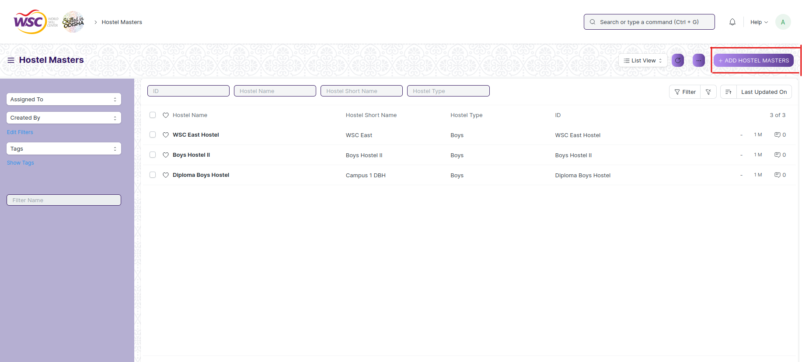

(Example : For addition in the new Hostel Masters, click +Add Hostel Masters button).

* Enter the required data.
* Click on “***Save”*.**
* After saving , the record will be visible in the List View of the screen.

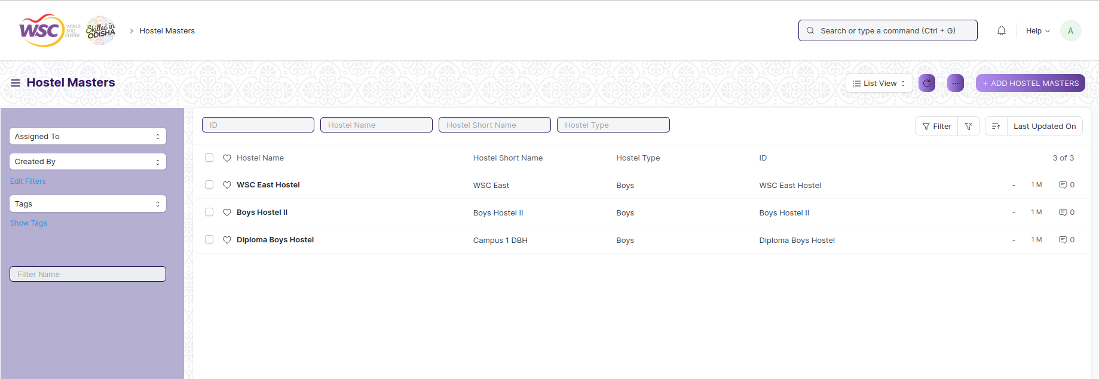

(Example : List view of saved Hostel Types)

**Note :** The process of creation can only be carried out by hostel employees who have necessary permission.Kindly refer to the Screen wise permission section in the document.

**View a Saved Document**

* Log in to the system.
* Go to the required workspace
* Go to the required screen.
* Click on the required document from the list view of the screen.

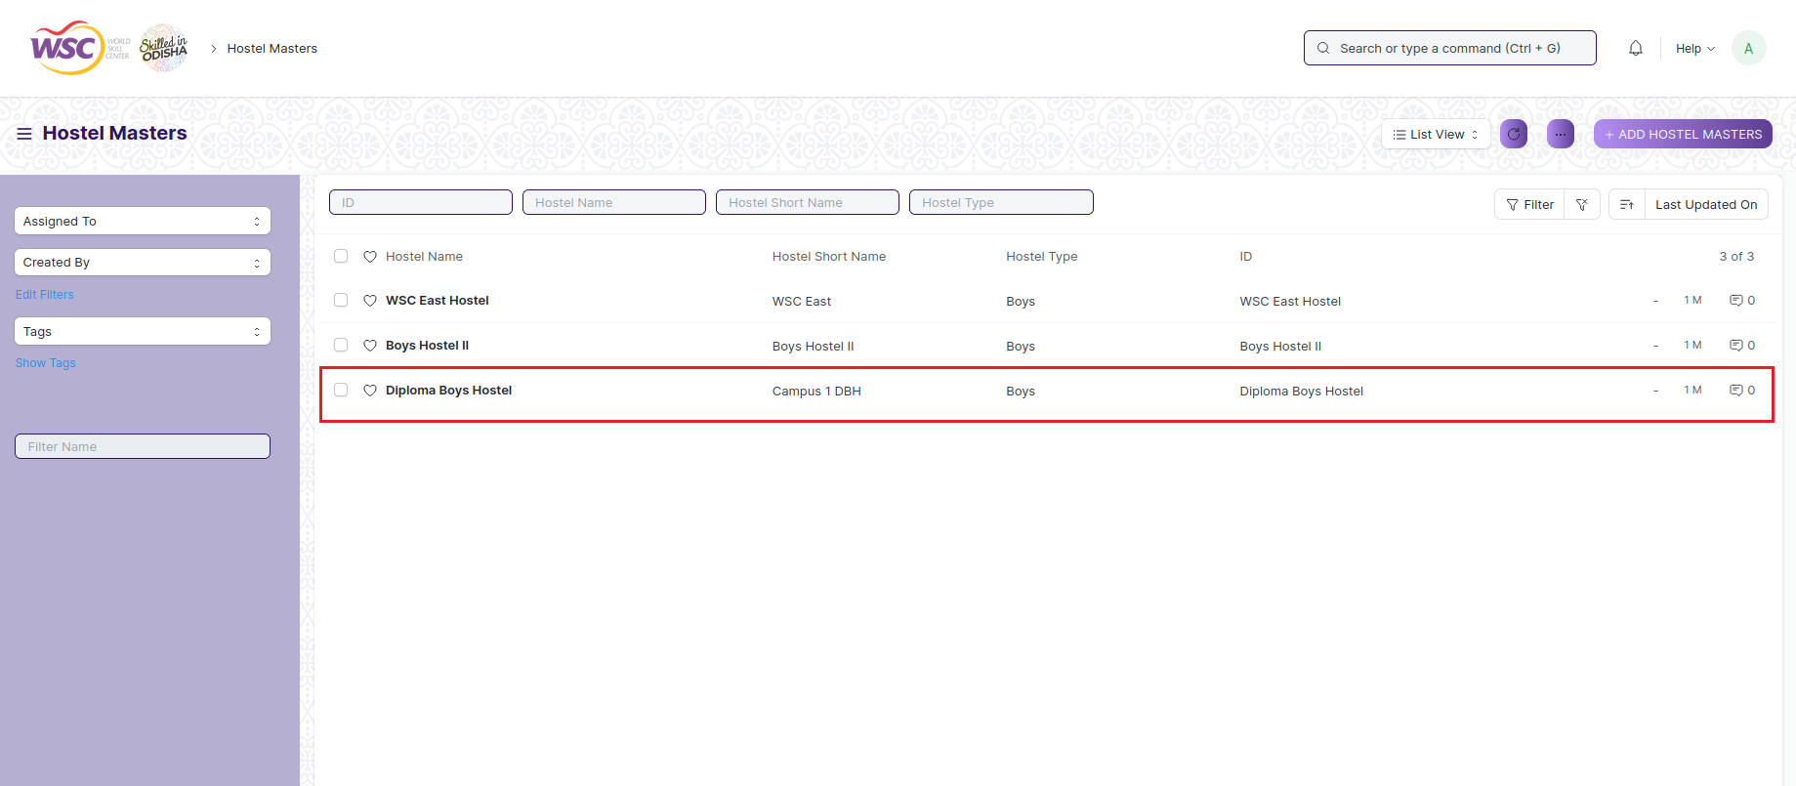

(Example : View of “Diploma Boys Hostel” Document of Hostel Masters Screen)

View the clicked document.

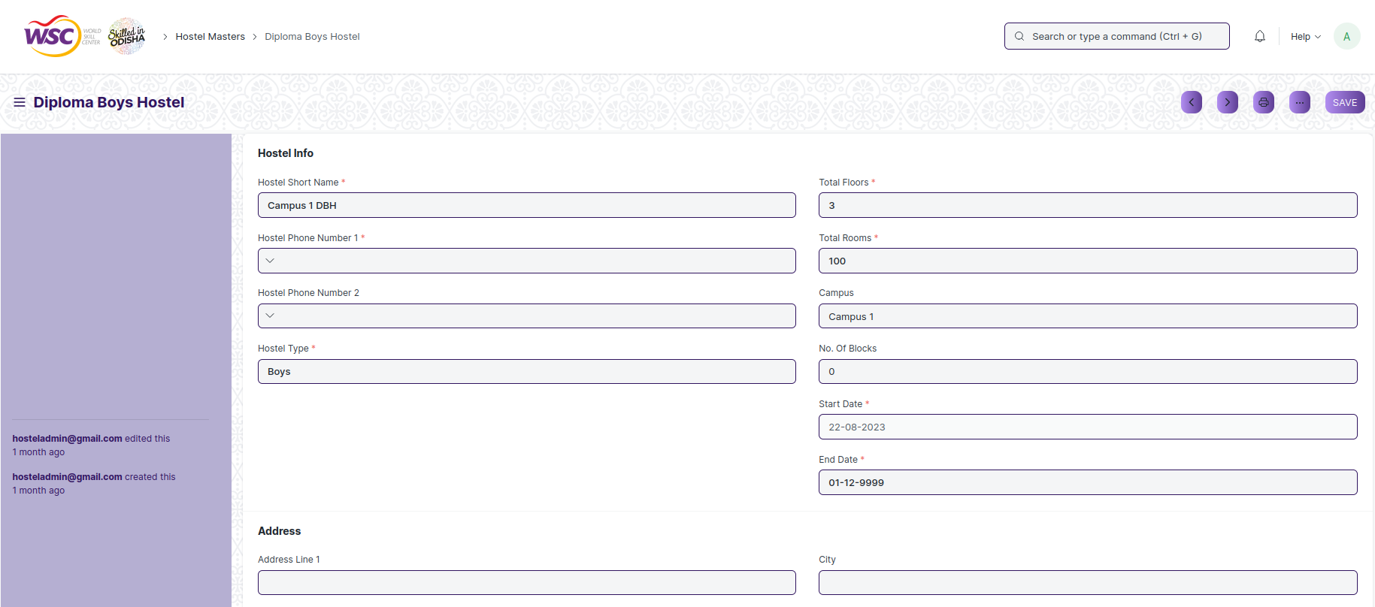

(Example : View of the “Diploma Boys Hostel” Hostel Masters)

**Note :** The process of view can only be carried out by hostel employees who have necessary permission.Kindly refer to the Screen wise permission section in the document.

**Delete a Saved Document**

* Log in to the system
* Go to the required workspace
* Go to the required screen.
* Click on the required document from the list view of the screen.
* Click on the 3 dots in the right corner of the screen.
* Click on *“****Delete”*.**

**Note :** If the document you are deleting is linked with any other document then first unlink it , then try to delete.

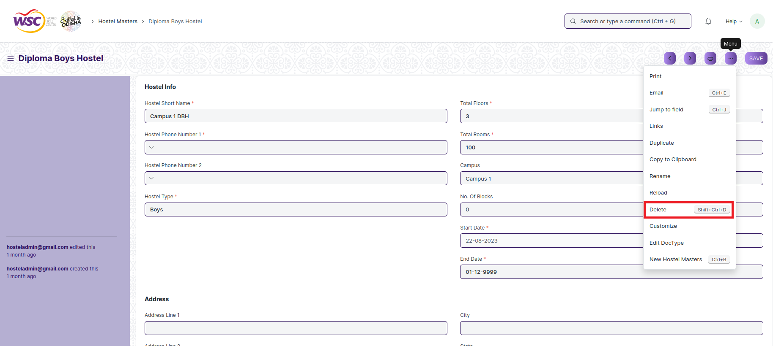

(Example : Deletion of “Diploma Boys Hostel” document of Hostel Masters)

* Click yes if you want to delete the selected document.

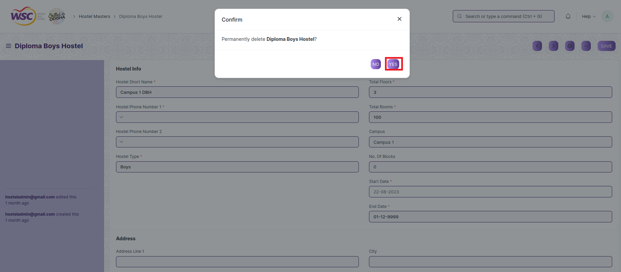

(Example : Clicking Yes to Delete permanently the document)

**Note :** The process of deletion can only be carried out by hostel employees who have necessary permission.Kindly refer to the Screen wise permission section in the document.

**Rename a Saved Document**

* Login to the screen.
* Go to the required workspace
* Go to the required screen.
* Click on the required document from the list view of the screen.
* Click on the 3 dots in the right corner of the screen.
* Click on *“****RENAME”*** .

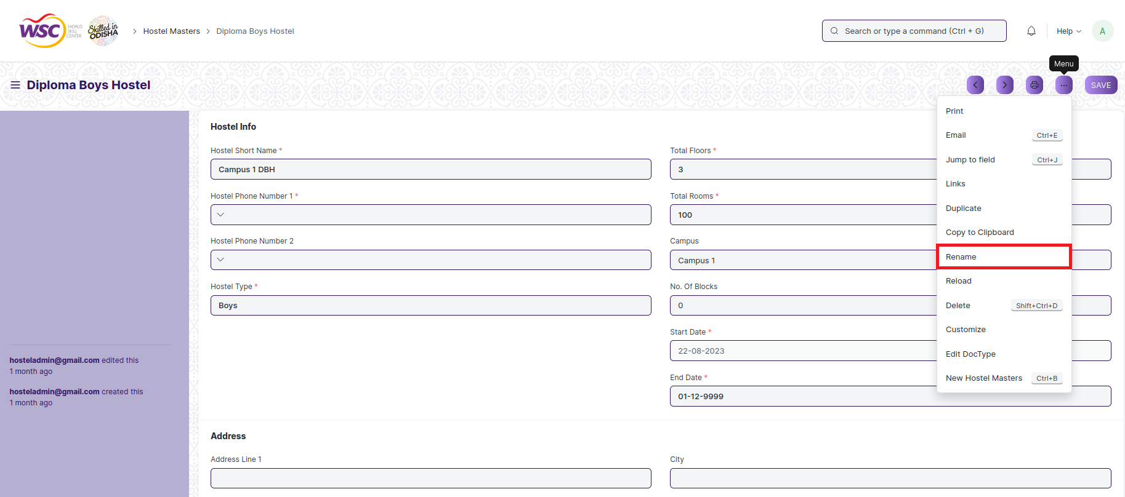

* Click on *“****Rename”*** button to rename the document.

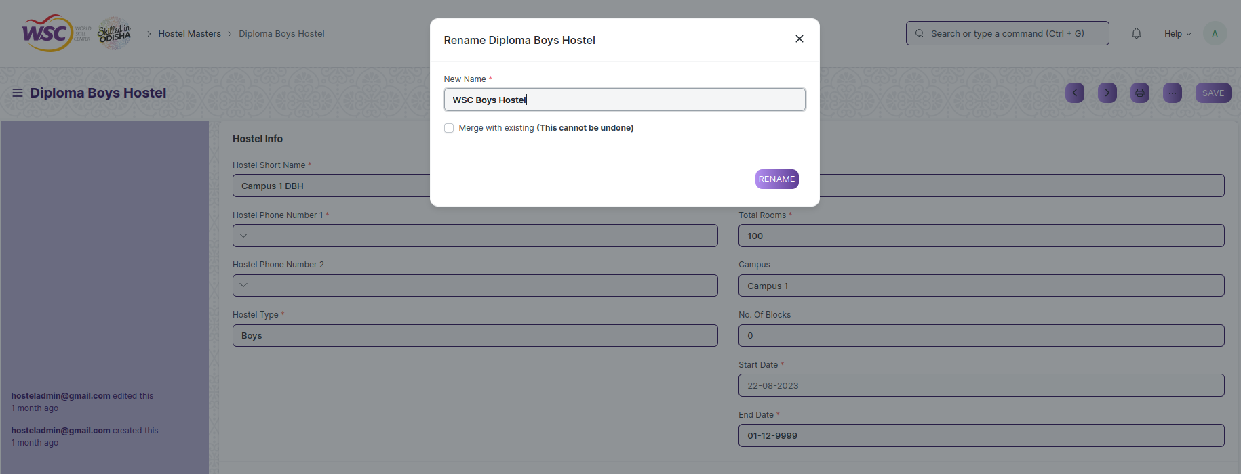

**Note :** The process of deletion can only be carried out by hostel employees who have necessary permission.Kindly refer to the Screen wise permission section in the document.

**Print a Saved Document type**

* Login to the system
* Go to the required workspace
* Go to the required screen.
* Click on a saved document on the screen.
* Click on the print button presented in the right corner of the screen.

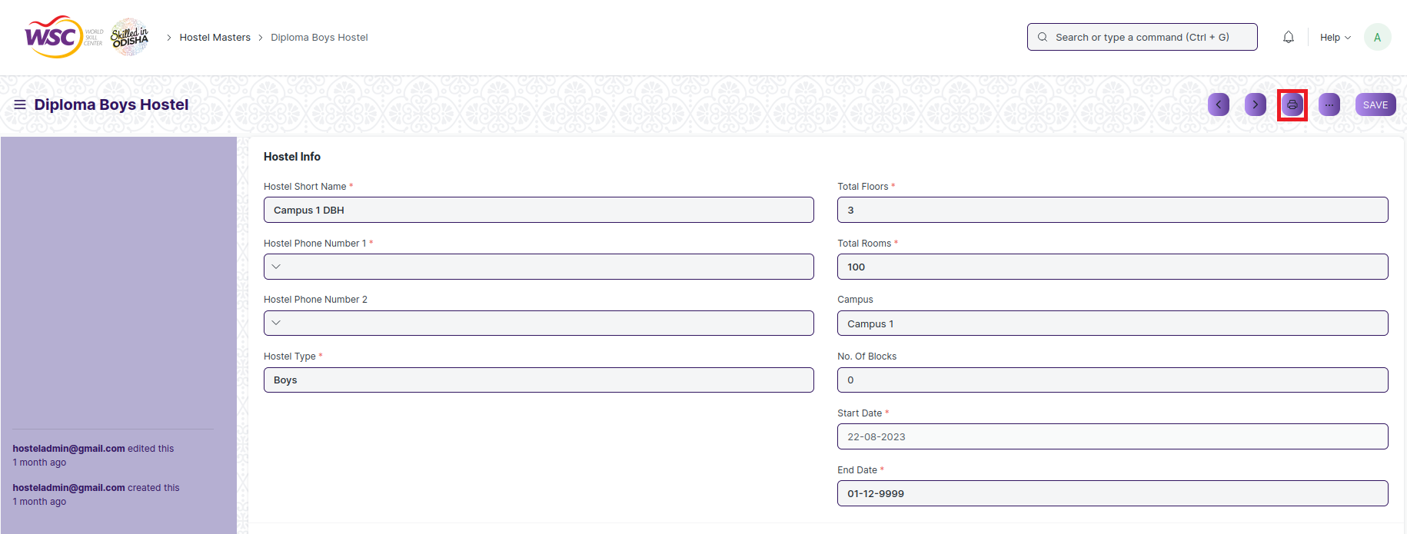

* A new screen will open.
* Click on the print button to print the document.

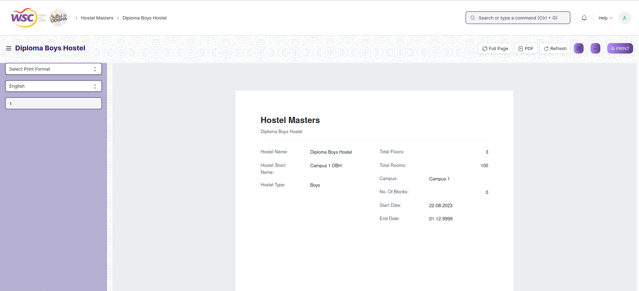

* To download the employment type as PDF , click on the PDF button .

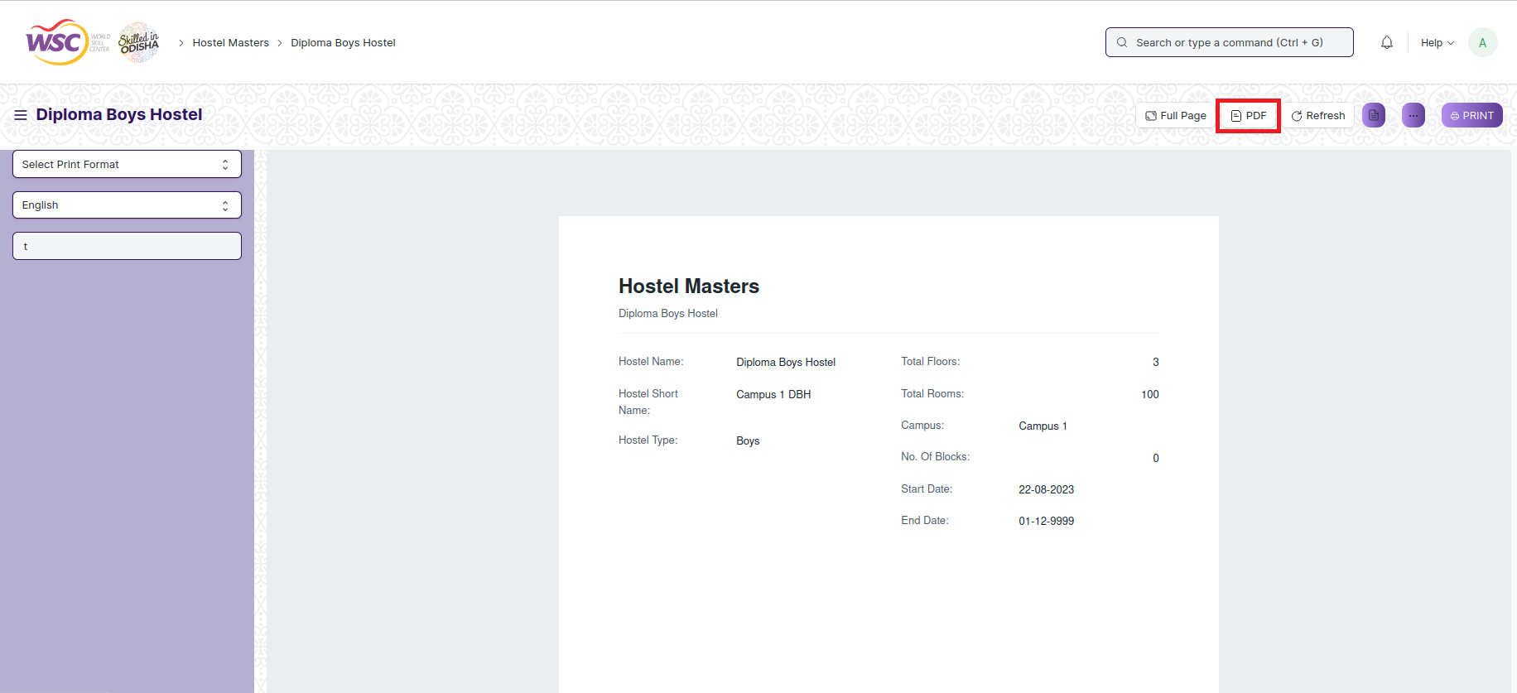

**Note :** The process of printing can only be carried out by hostel employees who have the necessary permission.

**View the saved document in different format.**

* Login to the system
* Go to the required workspace
* Go to the required screen.
* Click on the List View Button in the screen.

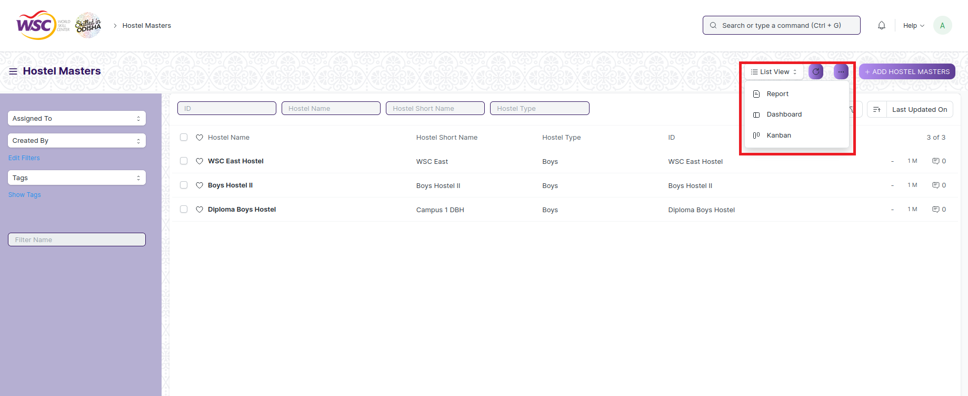

* Select the appropriate view type that you want.

**Note :** The List view button can only be showed to the hostel employees who have necessary permission.

**View the saved documents by applying filters.**

* Login to the screen.
* Go to the required workspace.
* Go to the required screen.
* Click on the ***“Filter”***.

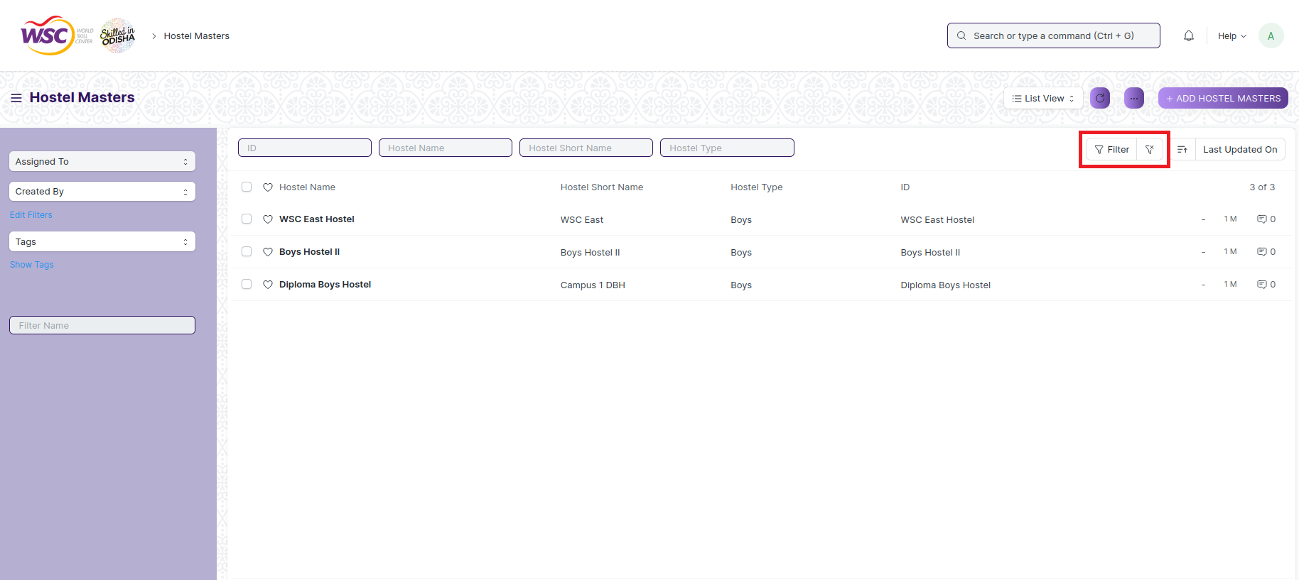

* Select the field of the document based on which you wish to filter the records. All the fields in a form will be selectable in this list.

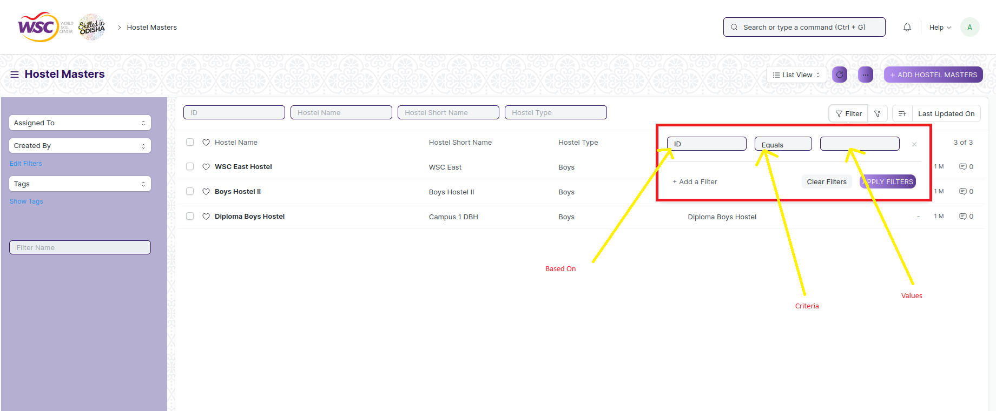

**Based On :** For the field, you will be required to put a value of the field. In the 'based on' field.

**Criteria :** You can define criteria based on which the system will search the document.The different conditions on which the filters are based are: Equals, Not Equal, Like, Not Like, In, Not In, =,>,< etc.

**Value :** Here, you will be required to enter the value for which you are running the document search.

**Some Examples of Viewing the documents in the list view after applying filters.**

Filter on Employee screen where Gender Equals to Male. After clicking the Apply Filter button, all the filtered document will show in the screen.

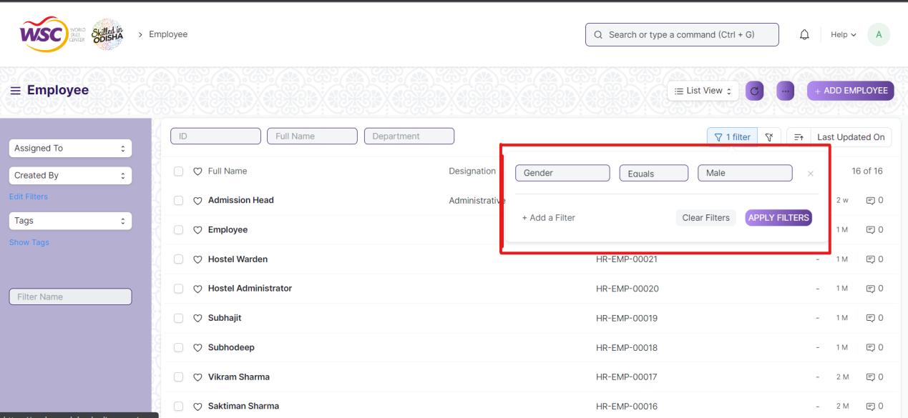

Filter on Employee Screen where, the full name starts with ‘A’.

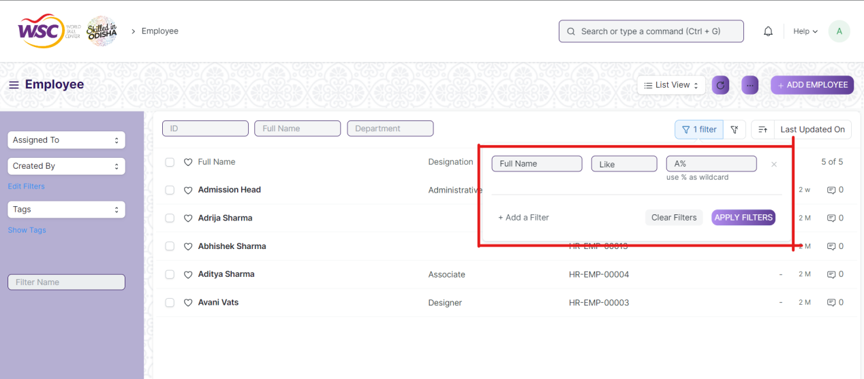

Filter on Employee Screen , where Date of Joining is greater than a particular date.

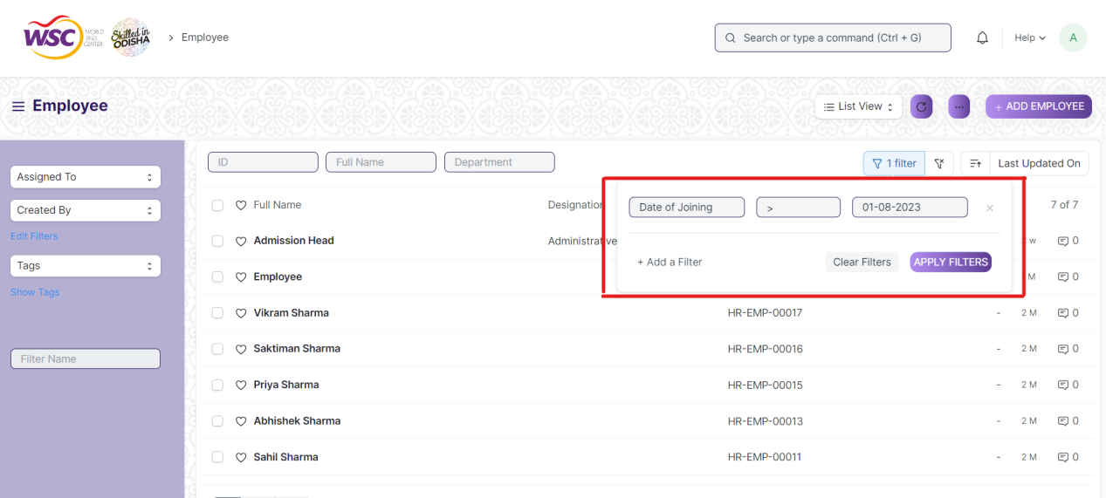

You can also apply multiple filters at a time. To remove a specific filter, just click on 'x' sign on it. To add another filter Click on the +Add a Filter button.

**Example of Multiple filter .**

Applying filter in the employee screen , where date of joining is greater than some date and gender is equal to Male.

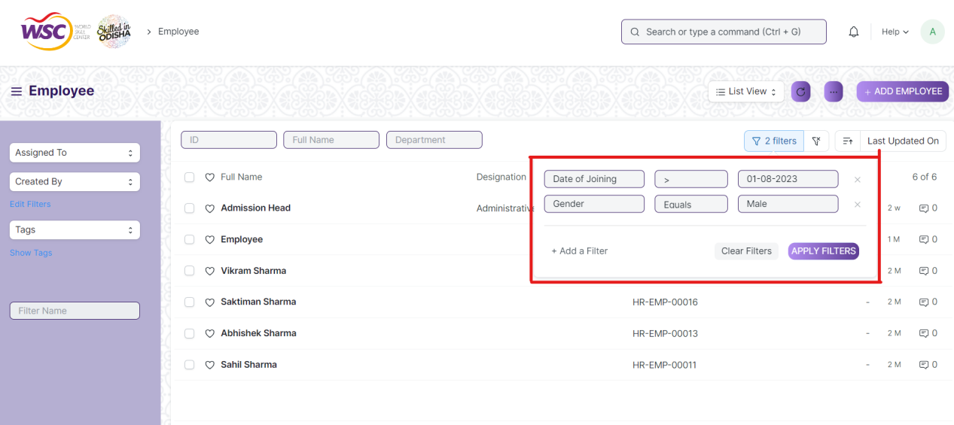

**Default Filters**

There are some filters present out of the box for the views which can be used for filtering the search results.

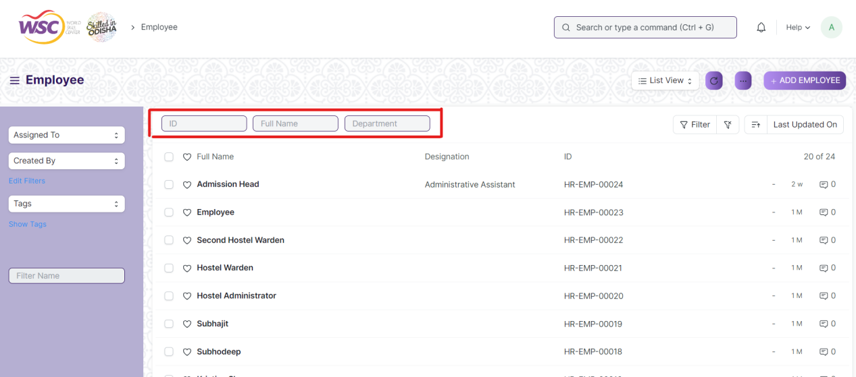

**Note :** The Filter Option can only be showed to the employees who have necessary permission.

## General Procedure for Submitted Document

**Create of New document**

* Login in to the system
* Go the required workspace
* Go to the required screen.
* Click on the ***“+Add Screen Name”*** button in the right corner of the screen.

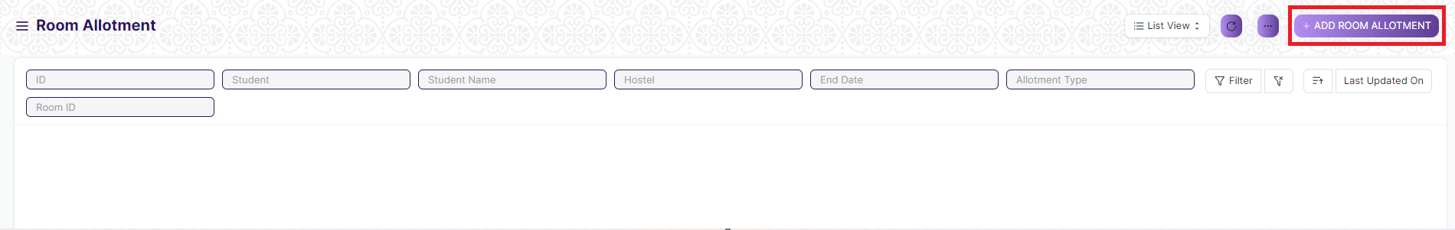

(Example : For addition in the new Room Allotment Type , click +Add Room Allotment Type button).

* Enter the required information in the document.
* Once you are finished entering the information , click the ***“Save”*** button.
* After saving it , a submit button will appear.

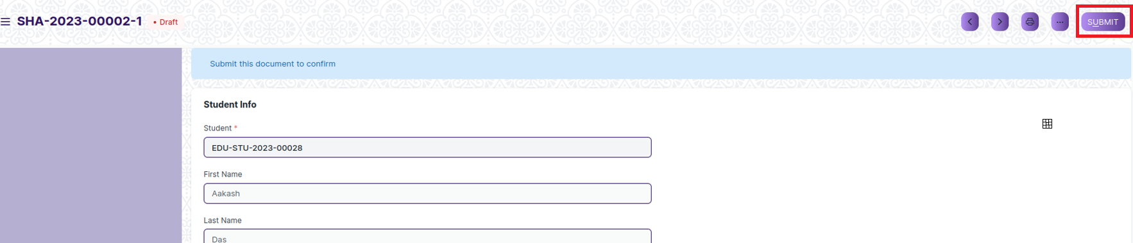

* Click on the **“Submit”** button.
* A confirmation dialog box will appear . Click the Yes button to submit the document.

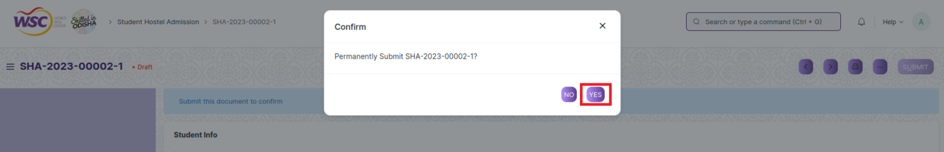

* After submitting , the record will be visible in the List View of the screen.

**Note :** The process of creation can only be carried out by employees who have necessary permission.Kindly refer to the Screen wise permission section in the document.

**Cancel a Submitted Document**

* Log in to the system.
* Go to the required workspace
* Go to the required screen.
* Click on the required document from the list view of the screen.
* Click the ***“Cancel”*** Button .

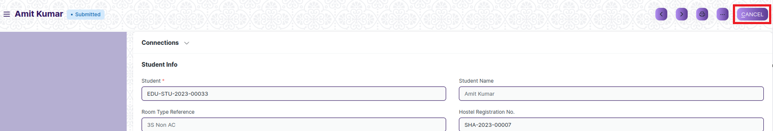

* A confirmation dialog box will appear . Click the Yes button to cancel the document.

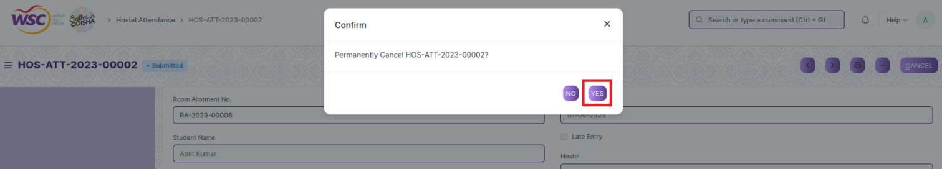

**Note :** The process of cancellation can only be carried out by employees who have necessary permission.Kindly refer to the Screen wise permission section in the document.

**Amend a Submittable Document**

* Log in to the system.
* Go to the required workspace
* Go to the required screen.
* Click on the required document from the list view of the screen.
* After cancellation of the document , an Amend button will appear on the screen.

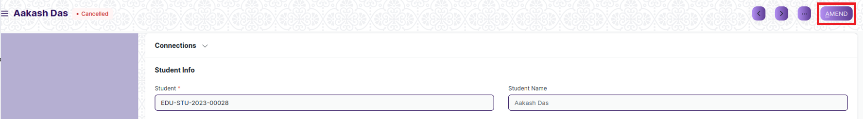

* Click the “***Amend”*** button.
* A new document will be created with the same information as the original document .

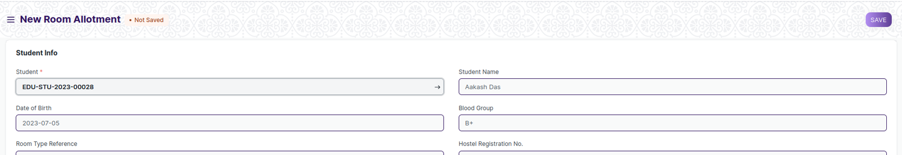

* You can now make changes to the document as needed.

**Note :** The process of Amend can only be carried out by employees who have necessary permission.Kindly refer to the Screen wise permission section in the document.

**Delete a Submittable Document**

* Log in to the system.
* Go to the required workspace
* Go to the required screen.
* Click on the required document from the list view of the screen.
* If the document is in draft sate , you can follow the procedure to delete a save document .
* If the document is submitted , then cancel it first , then delete it.

After cancellation of the document , an Amend button will appear on the screen.

**Note :** If the document you are deleting is linked with any other document , then cancel the dependent document first , then try to delete it.

Example :

In the Room Allotment Screen, when a Room Allotment record is Approved , then a record in the Room Allotment screen will be created. it is not allowed for deletion of the Room Allotment record until the associated Student Mortality record is canceled or deleted.

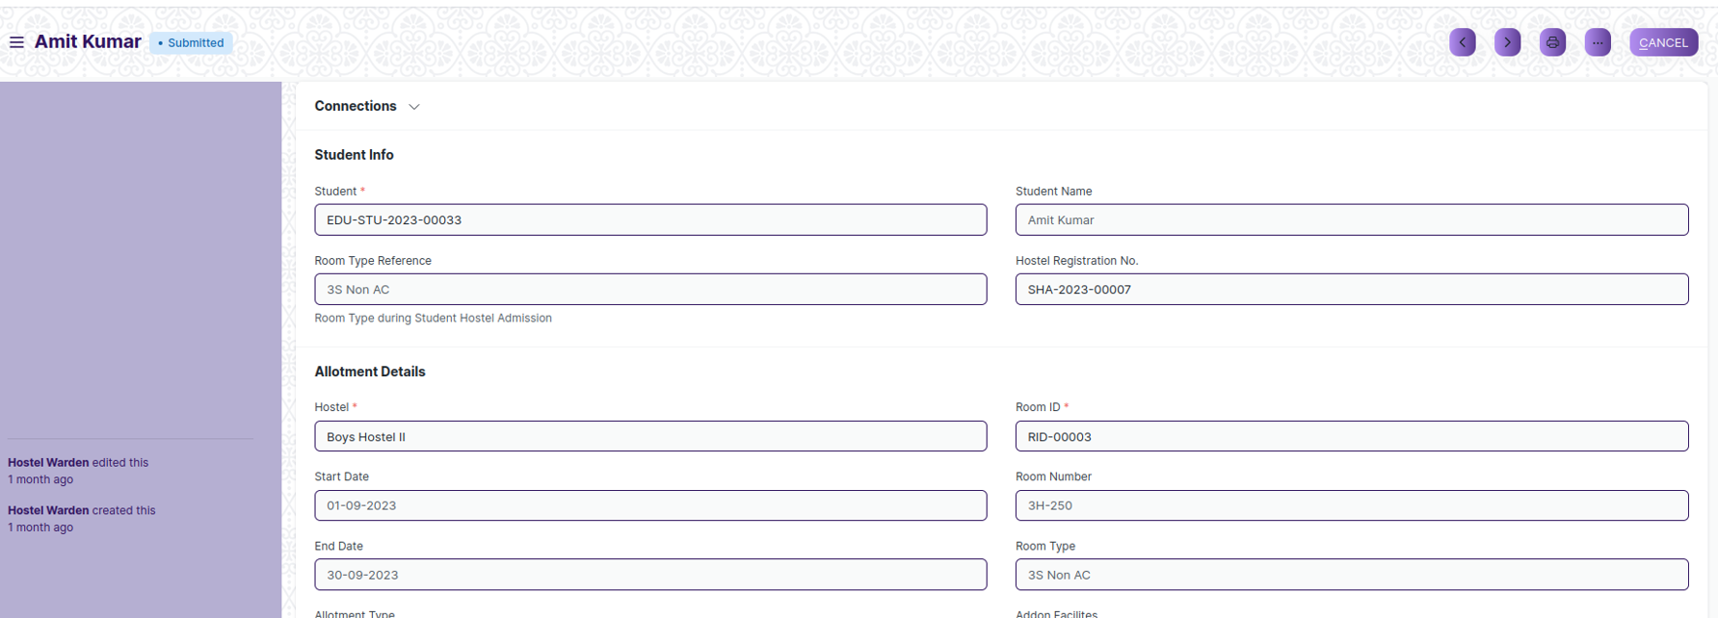

(Room Allotment Record **RA-2023-00006** linked with Student Mortality **DDA-2023-00003** )

On deletion of Room Allotment record, It will show the following message ,

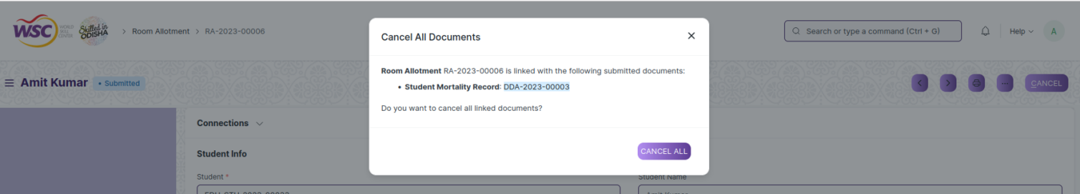

So go the following Student Mortality record document(**DDA-2023-00003)**, and cancel it first . After cancellation , user will able to delete the Room Allotment record **(RA-2023-00006)**.

**Note :** To initiate the cancellation process, kindly click on the link labeled **‘DDA-2023-00003’** which corresponds to the Room Allotment record."

**Action Menu on a document.**

The three dots menu, located in the right corner of a document in a Screen , offers a range of actions and options to manage and interact with the document.

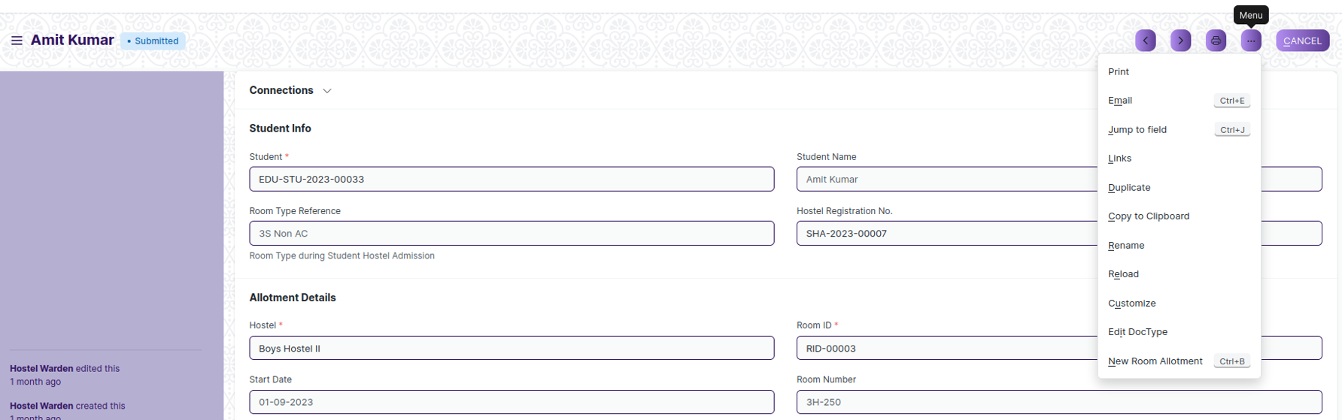

The functionalities available in the three dots menu are given below .

**Print :** Print Enables you to generate a printable version of the document ., which you can save as a PDF or send to a printer.

**Email :** Click on Email allows you to send the document as an attachment via email to specified recipients.

**Duplicate :** Create a new document with the same information as the current one.

**Delete :** Permanently remove the document.

**Cancel :** Cancel the submitted document.

**Submit :** Submit the document . If the document is submittable.

**Links :** This Option displays a list of document that are linked to the current document. You can navigate these linked documents from here.

**Jump to field :** You can directly go the required field by clicking this option and giving appropriate field name.

**Copy to Clipboard :** By clicking this option you can copy the content of the document .

**Rename :** By clicking the Rename option you can Rename the document.

**Note :** These options will be visible to employees who have necessary permission.

# Master Screens

## Hostel Masters

The “Hostel Master” screen is where all action takes place and is used to display information about the hostel's rooms, kind, residents, address, and other pertinent data.

The screen is accessible to Hostel Warden and Hostel Superintendent.

To access the Hostel Masters Master screen ,go to :

***Home > Hostel > Masters > Hostel Masters***

Screen Type : Save

**Prerequisites**

Before creating an Hostel Masters, it is advisable you create the following documents:

* Hostel Type

**Adding a new Hostel Masters**

As it is a save screen, follow the general procedure to create a save document as mentioned above .

* Go to the Hostel Masters list, click on New.
* Enter the Details.
* Save.

After creating an Hostel Masters , the record will be visible in the List view of the screen.

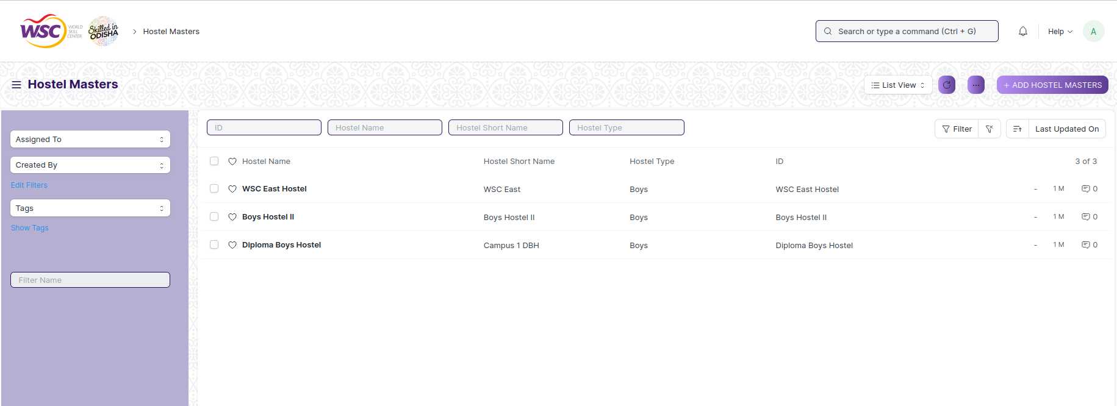

(List View of Hostel Masters)

**Note** : The Hostel Masters can be linked to the Room Master, Employee Hostel Allotment, Student Hostel Admission, Room Allotment etc.

**View Hostel Masters**

As it is a save screen, follow the general procedure to view a save document as mentioned above .

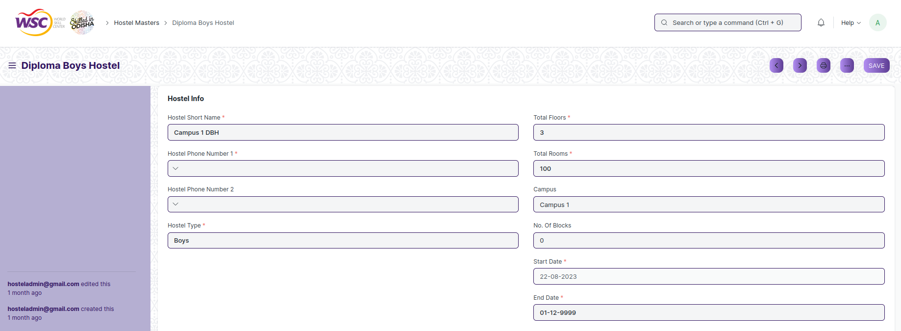

(View of a saved Hostel Masters)

**Delete Hostel Masers**

As it a Save screen , follow the general procedure to delete a save document .

**Edit Hostel Masters**

Follow the steps to view a saved hostel masters.

Edit the field that you want to change.

Click on Save.

**Print Hostel Masters**

As it is a Save screen , follow the general procedure to print a saved document.

**View Hostel Masters in different format**

As it is a Save screen , follow the general procedure to view a saved document in different format.

## Room Masters

The “Room Masters” screen show the details of rooms for particular hostel. Here user mention room capacity, description, type and feature.

The screen is accessible to Hostel Warden and Hostel Superintendent.

To access the Room Master screen ,go to :

***Home > Hostel > Masters > Room Masters***

**Screen Type :** Save

**Prerequisites**

Before creating an Room Masters, it is advisable you create the following documents:

* Hostel Masters
* Room Description
* Room Type

**Note** : The Room Masters can be linked to the Student Hostel Admission, Room Allotment etc.

**Adding a new Room Masters**

As it is a save screen, follow the general procedure to create a save document as mentioned above .

* Go to the Room Masters list, click on New.
* Enter the Details.
* Save.

After creating an Room Masters , the record will be visible in the List view of the screen.

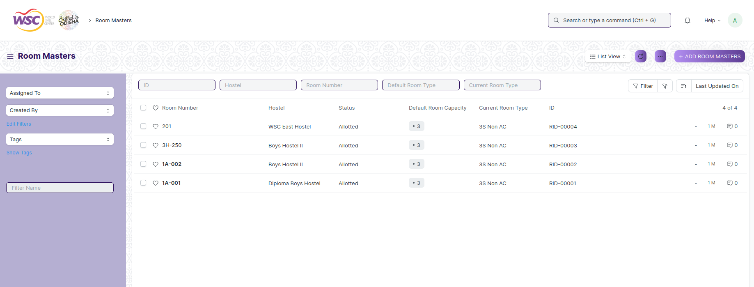

(List View of Room Masters)

**View Room Masters**

As it is a save screen, follow the general procedure to view a save document as mentioned above .

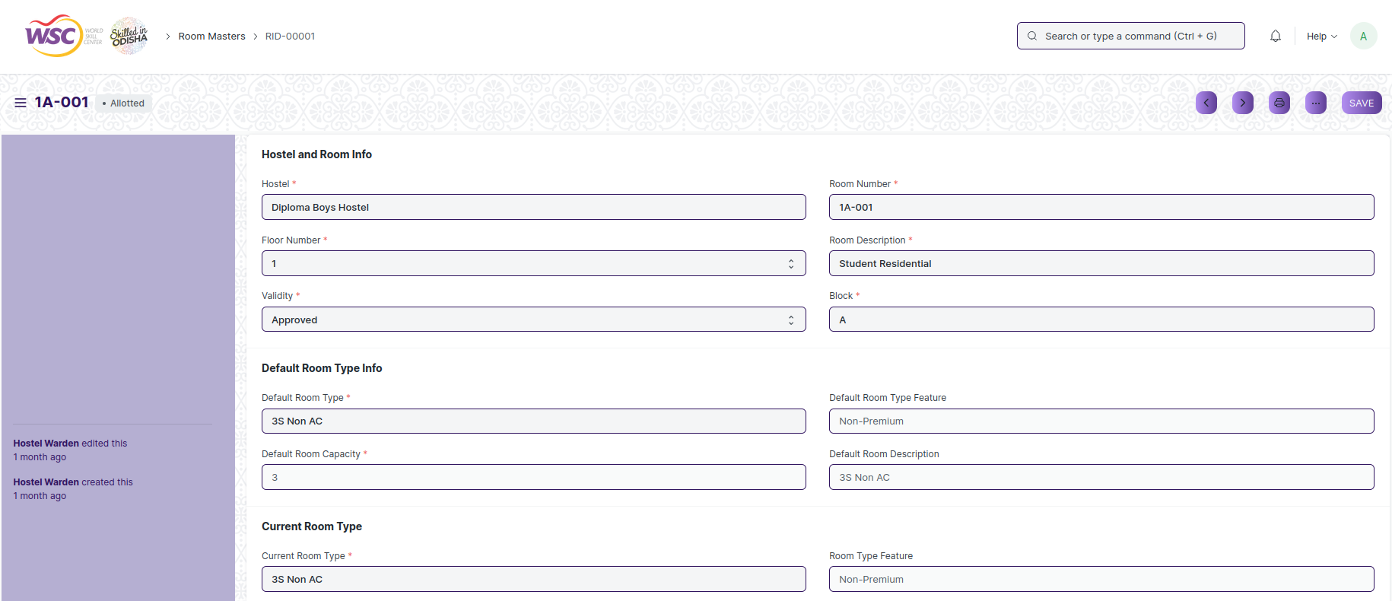

(View of a saved Room Masters.)

**Delete Room Masters**

As it a Save screen , follow the general procedure to delete a save document .

**Edit Room Masters**

Follow the steps to view a saved Room Masters document.

Edit the field that you want to change.

Click on Save.

**Print Room Masters**

As it is a Save screen , follow the general procedure to print a saved document.

**View Room Masters Type in different format**

As it is a Save screen , follow the general procedure to view a saved document in different formats.

## Hostel Type

**Hostel Type is a master screen where user can define type of hostel.**

The screen is accessible to Hostel Warden and Hostel Superintendent.

To access the Hostel Type screen ,go to :

***Home > Hostel > Masters > Hostel Type***

Screen Type : Save

**Adding a new Hostel Type**

As it is save screen, follow the general procedure to create a save document type as mentioned above.

* Go to the Hostel Type list, click on New.
* Enter the Details.
* Save.

After creating a Hotel Type , the record will be visible in the List view of the screen.

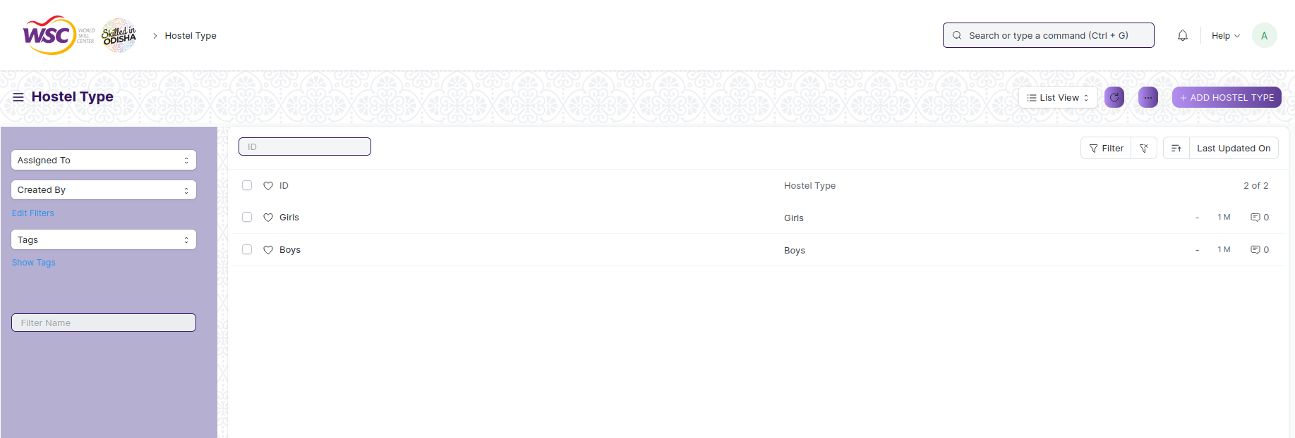

(List View of Hostel Type)

**View Hostel Type**

As it is a save screen, follow the general procedure to view a save document as mentioned above .

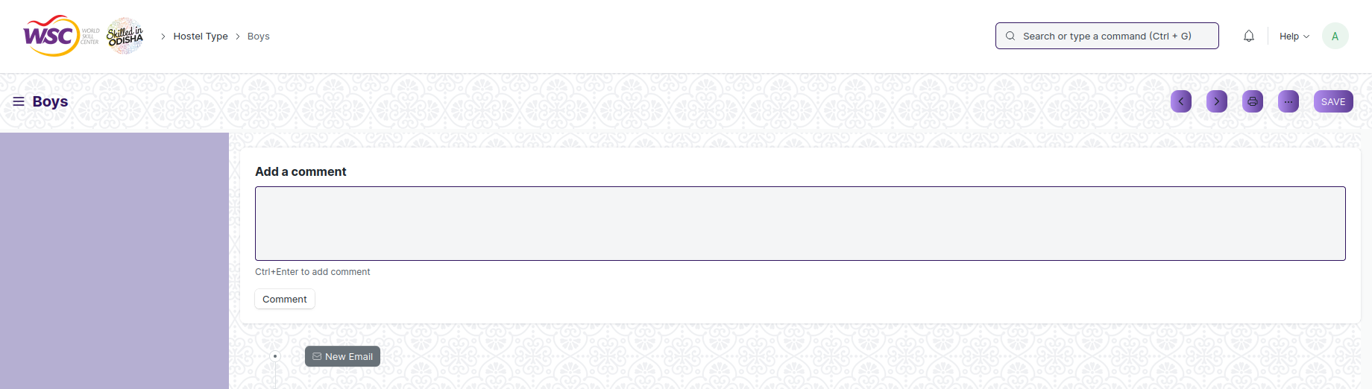

(View of a saved Hostel Type.)

**Delete Hostel Type**

As it a Save screen , follow the general procedure to delete a save document .

**Edit Hostel Type**

Follow the steps to view a saved Hostel Type document.

Edit the field that you want to change.

Click on Save.

**Print Hostel Type**

As it is a Save screen , follow the general procedure to print a saved document.

**View Hostel Type in different format**

As it is a Save screen , follow the general procedure to view a saved document in different format.

## Room Type

Room **Type is a master screen where user can define the type of Room.** It can be Ac and Non-Ac. Also user can mention Feature like Premium, Non-Premium and Super-Premium.

The screen is accessible to Hostel Warden and Hostel Superintendent.

To access the Room Type screen ,go to :

***Home > Hostel > Masters > Room Type***

Screen Type : Save

**Adding a new Room Type**

As it is save screen, follow the general procedure to create a save document type as mentioned above.

* Go to Room Type list, click on New.
* Enter the Details.
* Save.

After creating a Room Type , the record will be visible in the List view of the screen.

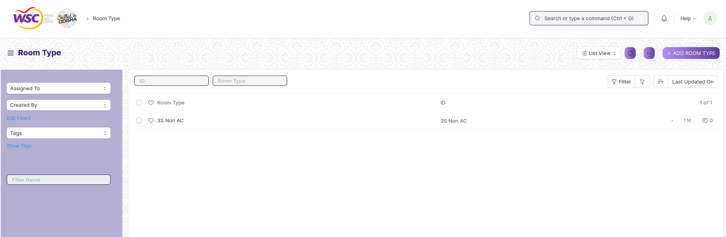

(List View of Room Type)

**View Room Type**

As it is a save screen, follow the general procedure to view a save document as mentioned above .

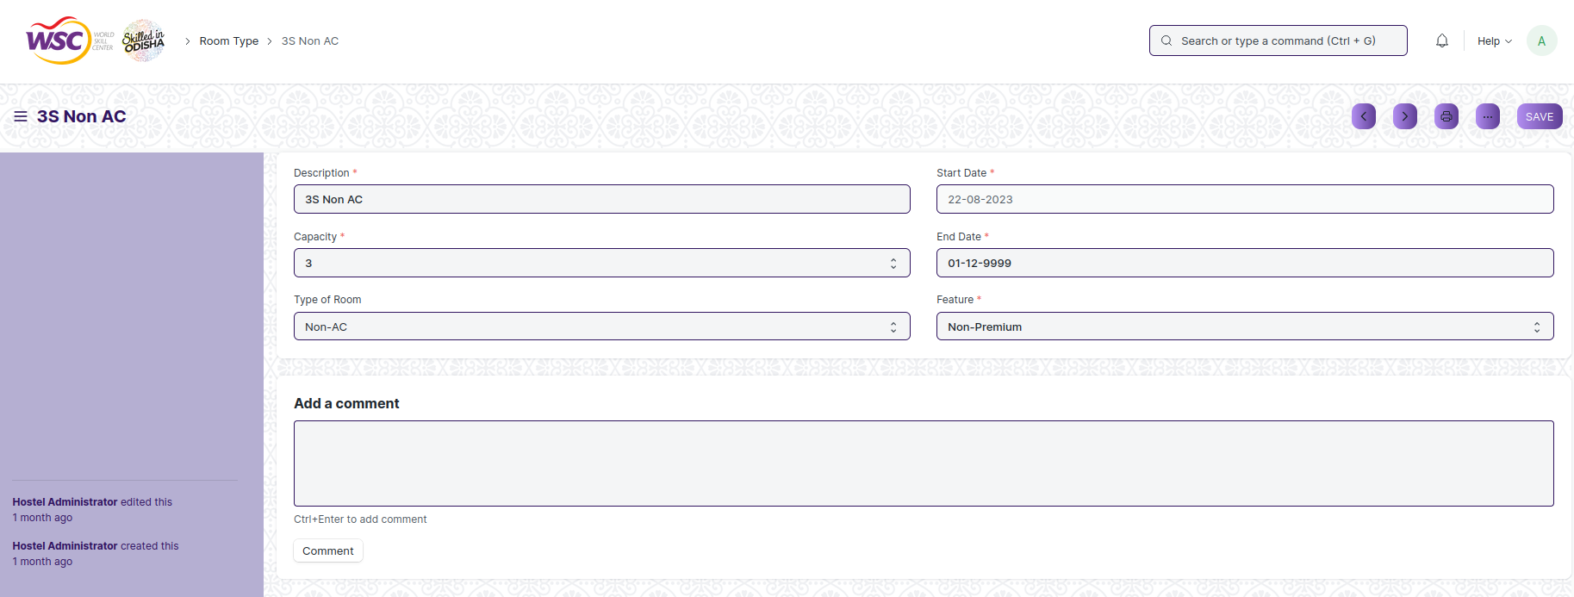

(View of a saved Room Type.)

**Delete Room Type**

As it a Save screen , follow the general procedure to delete a save document .

**Edit Room Type**

Follow the steps to view a saved Room Type document.

Edit the field that you want to change.

Click on Save.

**Print Room Type**

As it is a Save screen , follow the general procedure to print a saved document.

**View Room Type in different format**

As it is a Save screen , follow the general procedure to view a saved document in different format.

## Room Description

The Room Description allow user to give full description about the room **and Status of the room.**

The screen is accessible to Hostel Warden and Hostel Superintendent.

To access the Room Description screen ,go to :

***Home > Hostel > Masters > Room Description***

Screen Type : Save

**Adding a new Room Description**

As it is a save screen, follow the general procedure to create a save document type as mentioned above.

* Go to Room Description list, click on New.
* Enter the Details.
* Save.

After creating a Room Description, the record will be visible in the List view of the screen.

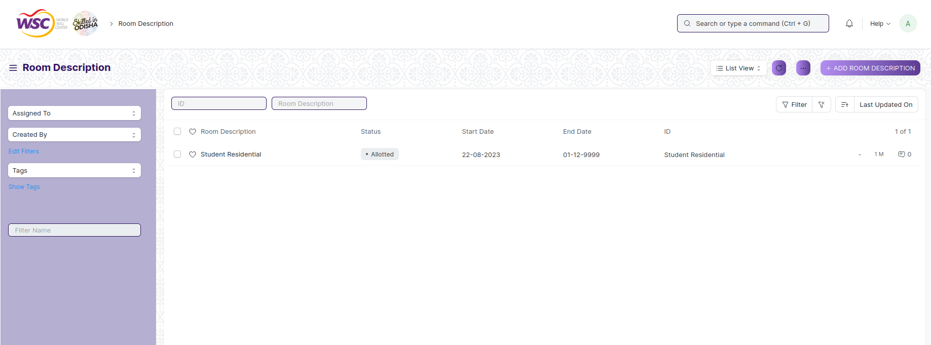

(List View of Room Description)

**View Room Description**

As it is a save screen, follow the general procedure to view a save document as mentioned above .

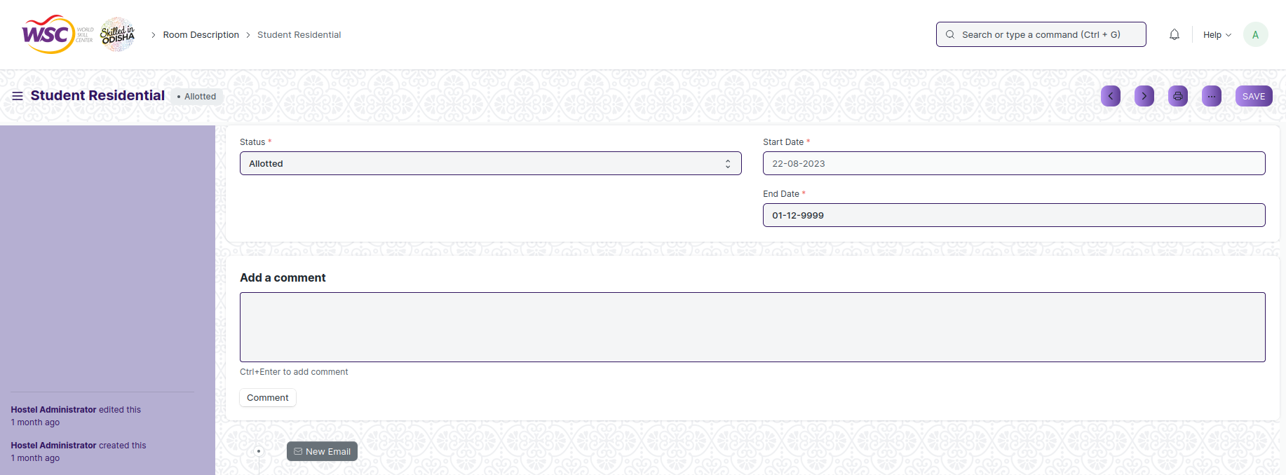

(View of a saved Room Description.)

**Delete Room Description**

As it a Save screen , follow the general procedure to delete a save document .

**Edit Room Description**

Follow the steps to view a saved Room Description document.

Edit the field that you want to change.

Click on Save.

**Print Room Description**

As it is a Save screen , follow the general procedure to print a saved document.

**View Room Description in different format**

As it is a Save screen , follow the general procedure to view a saved document in different format.

## Employee Hostel Allotment

The Employee Hostel Allotment allow user to give information about the employee who will be allotted or in charge of the hostel.

The screen is accessible to Hostel Warden and Hostel Superintendent.

To access the Employee Hostel Allotment screen ,go to :

***Home > Hostel > Masters > Employee Hostel Allotment***

Screen Type : Save

**Prerequisites**

Before creating an Employee Hostel Allotment, it is advisable you create the following documents:

* Employee
* Hostel Masters

**Adding a new Employee Hostel Allotment**

As it is save screen, follow the general procedure to create a save document type as mentioned above.

* Go to Employee Hostel Allotment list, click on New.
* Select and add employee ID. The employee name,user name will be automatically fetched.
* Enter the Start Date and End Date.
* Select the Hostel Masters.
* Select the Role.
* Click on Save.

After creating a Employee Hostel Allotment , the record will be visible in the List view of the screen.

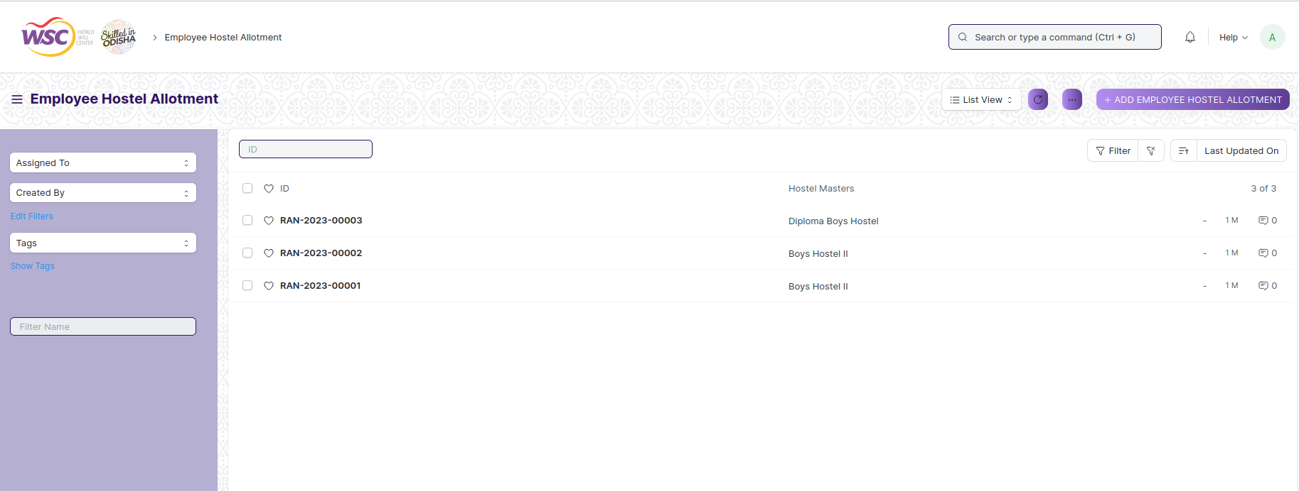

(List View of Employee Hostel Allotment)

**View Employee Hostel Allotment**

As it is a save screen, follow the general procedure to view a save document as mentioned above .

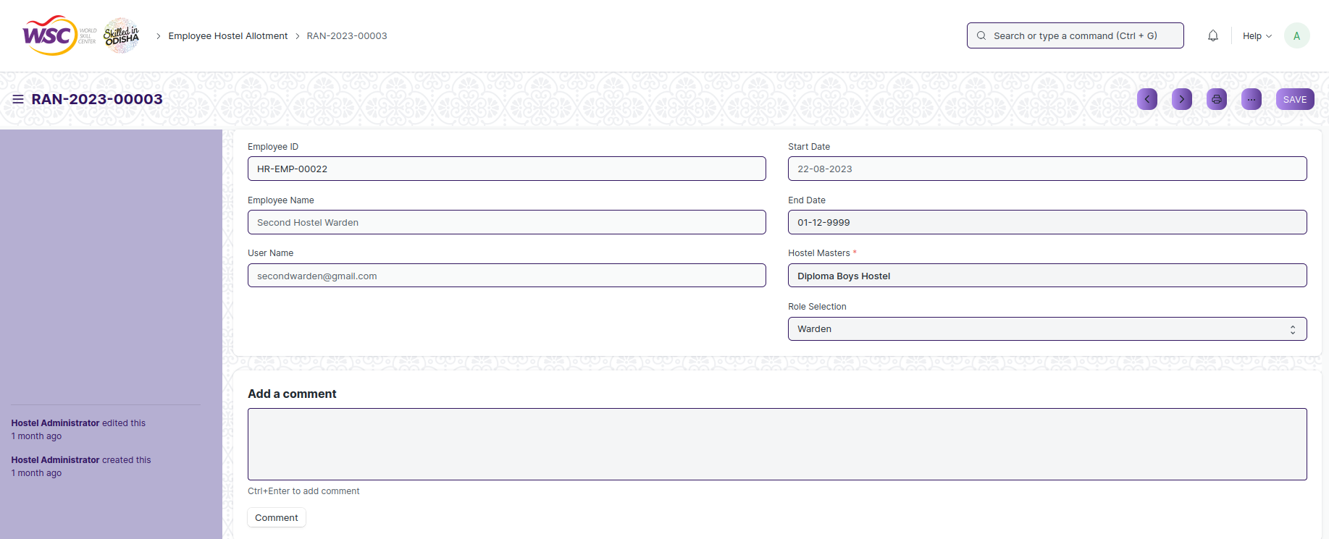

(View of a saved Employee Hostel Allotment.)

**Delete Employee Hostel Allotment**

As it a Save screen , follow the general procedure to delete a save document .

**Edit Employee Hostel Allotment**

Follow the steps to view a saved Employee Hostel Allotment document.

Edit the field that you want to change.

Click on Save.

**Print Employee Hostel Allotment**

As it is a Save screen , follow the general procedure to print a saved document.

**View Employee Hostel Allotment in different format**

As it is a Save screen , follow the general procedure to view a saved document in different format.

# Hostel Enrollment & Process

## Student Hostel Admission

The Student Hostel Admission refer to the process by which the initial information of the student is registered for a room in the hostel.

The screen is accessible to Hostel Warden and Hostel Superintendent.

To access the Student Hostel Admission screen ,go to :

***Home>Hostel>Student Admission & Essentials>Student Hostel Admission***

Screen Type : Save & Submit.

**Prerequisites**

Before creating Student Hostel Admission, it is advisable you create the following documents:

* Student
* Hostel Masters
* Room type
* Fee Structure Hostel (If hostel fee is applicable)
* Fee Category (If hostel fee is applicable)

**Adding a new Student Hostel Admission**

As it is a Submit screen, follow the general procedure to create a Submit document as mentioned above .

After creating Student Hostel Admission , the record will be visible in the List view of the screen.

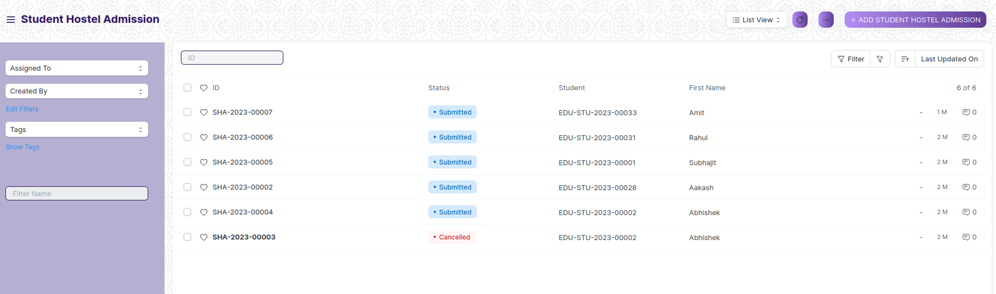

1. Go to Student Hostel Admission list, click on New.
2. All the mandatory fields are marked with red asterisks.
3. The Student field is linked to the Student form. Only those student has checked Hostel Required in student doctype that students will be displayed.
4. First Name,Last Name,Email Address,Roll No,Registration Number,Current Education will auto fetch from Student.
5. The Hostel field is linked to the Hostel Masters form.
6. Hostel Phone Number,Hostel Type will auto fetch (Field Visible when data selected from Hostel)
7. The Room Type field is linked to the Room Masters form.
8. Capacity,Type of Room,Feature will auto fetch (Field Visible when data selected from Room Type)
9. Click on Save and Submit

**View Student Hostel Admission**

As it is a Submit screen, follow the general procedure to view a Submit document as mentioned above .

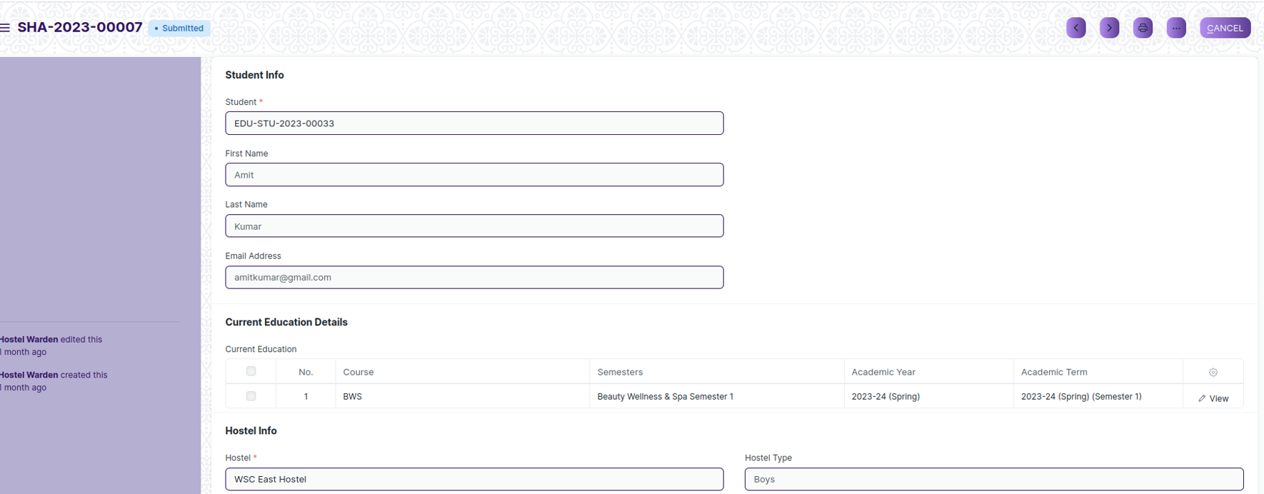

View of a Submit Student Hostel Admission.

**Cancel Student Hostel Admission**

As it is a submittable screen, follow the general procedure to Cancel a submittable document as mentioned above.

**Delete Student Hostel Admission**

If the document is submitted, follow the procedure to delete the submittable document.

**Amend Student Hostel Admission**

As it is a submittable screen , follow the general procedure to Amend the document.

**Edit Student Hostel Admission**

Once the document is submitted , it cannot be edited.

**Print Student Hostel Admission**

Follow the general procedure to print a submit document.

**View Student Hostel Admission Type in different format**

As it is a Submit screen , follow the general procedure to view a submitted document in different format.

## Student Medical History

The Student Medical History helps to maintain information about Student medical related information like Allergies, Post Medical History etc.

The screen is accessible to Hostel Warden and Hostel Superintendent,Student.

To access the Student Medical History screen ,go to :

***Home>Hostel>Student Admission & Essentials>Student Medical History***

Screen Type : Save

**Prerequisites**

Before creating an Student Medical History, it is advisable you create the following documents:

* Room Allotment

**Adding a new Student Medical History**

As it is save screen, follow the general procedure to create a save document type as mentioned above.

1. Go to Student Medical History list, click on New.
2. Select Allotment Number, with this all related data will fetch.
3. Check required Allergies and Past Medical History
4. Attach required document
5. And fill all important data
6. Click on save

After creating a Student Medical History, the record will be visible in the List view of the screen.

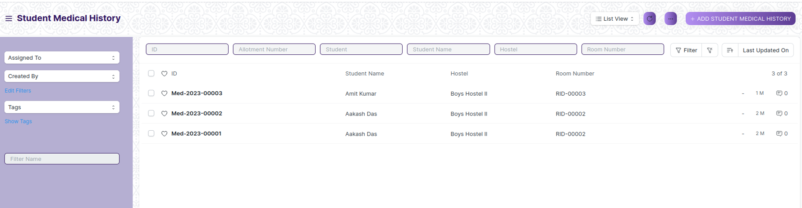

(List View of Student Medical History)

**View Student Medical History**

As it is a save screen, follow the general procedure to view a save document as mentioned above .

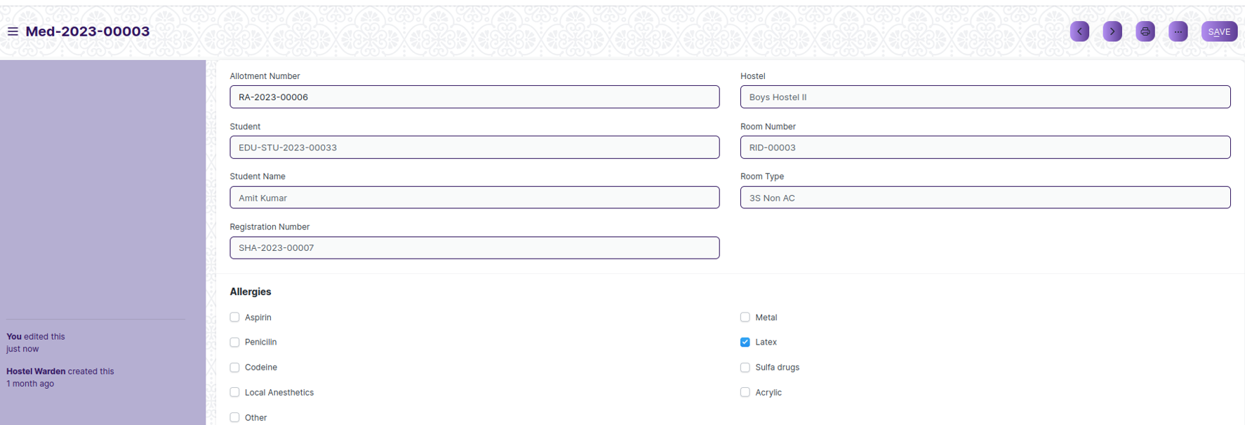

(View of a saved Student Medical History.)

**Delete Student Medical History**

As it a Save screen , follow the general procedure to delete a save document .

**Edit Student Medical History**

Follow the steps to view a saved Student Medical History document.

Edit the field that you want to change.

Click on Save.

**Print Student Medical History**

As it is a Save screen , follow the general procedure to print a saved document.

**View Student Medical History in different format**

As it is a Save screen , follow the general procedure to view a saved document in different format.

## Student Leave Process

The Student Leave process is allow issuing leave for student. This form helps maintain leave record of students residing in hostels.

The screen is accessible to Hostel Warden and Hostel Superintendent,Student.

To access the Student Leave Process screen ,go to :

***Home>Hostel>Student Admission & Essentials>Student Leave Process***

Screen Type : Save

**Prerequisites**

Before creating Student Leave Process, it is advisable you create the following documents:

* Room Allotment

**Adding a new Student Leave Process**

As it is a Submit screen, follow the general procedure to create a Submit document as mentioned above .

After creating Student Leave Process , the record will be visible in the List view of the screen.

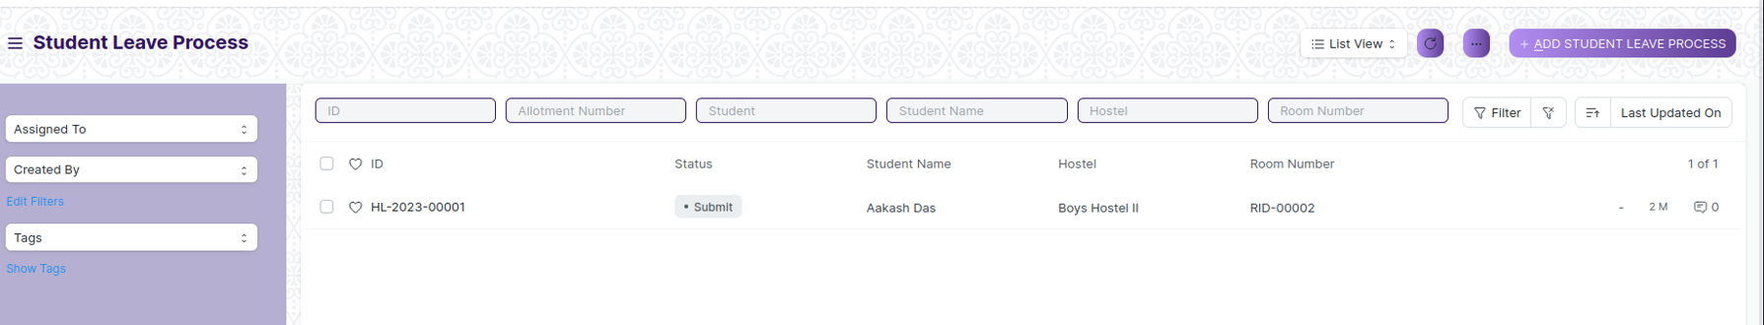

1. Go to Student Leave Process list, click on New.
2. Select Allotment Number according to this data all related data will fetch accordingly
3. Select Start data and End date
4. Write Application on application field
5. Attach parent application
6. Click on Save
7. After Save, Workflow is started:

Configure the workflow with the following stages:

**Stage 1**: Submit

Description: Initial stage when the Hostel Leave is created.

Allowed Transitions: Approved by Hostel Warden

**Stage 2**: Approved

Description: The Hostel Leave is Approved by Hostel Warden.

Allowed Transitions: Rejected

**Stage 3**: Rejected

Description:The Hostel Leave is Rejected by Hostel Warden.

**View Student Leave Process**

As it is a Submit screen, follow the general procedure to view a Submit document as mentioned above .

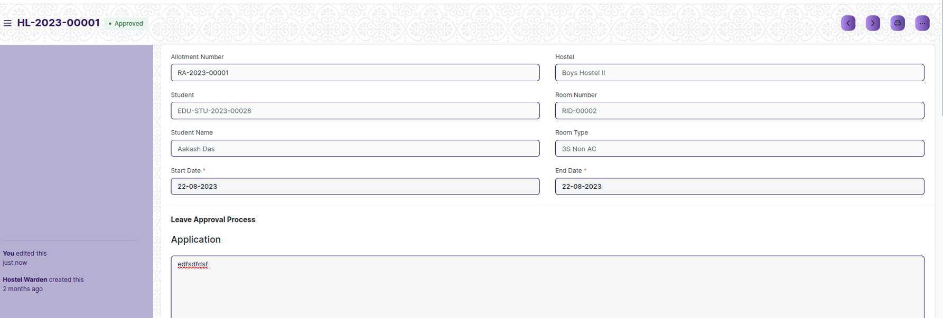

View of a Submit Student Hostel Admission.

**Cancel Student Leave Process**

As it is a submittable screen, follow the general procedure to Cancel a submittable document as mentioned above.

**Delete Student Leave Process**

If the document is submitted, follow the procedure to delete the submittable document.

**Amend Student Leave Process**

As it is a submittable screen , follow the general procedure to Amend the document.

**Edit Student Leave Process**

Once the document is submitted , it cannot be edited.

**Print Student Leave Process**

Follow the general procedure to print a submit document.

**View Student Leave Process Type in different format**

As it is a Submit screen , follow the general procedure to view a submitted document in different format.

## Material Distribution

The Material Distribution is allow to maintain item which is distributed to student for the first time after admission like bed, chair, table etc.

The screen is accessible to Hostel Warden and Hostel Superintendent.

To access the Material Distribution screen ,go to :

***Home>Hostel>Student Admission & Essentials>Material Distribution***

Screen Type : Save and Submit

**Prerequisites**

Before creating Material Distribution, it is advisable you create the following documents:

* Room Allotment
* Material Distribution Master

**Adding a new Material Distribution**

As it is a Submit screen, follow the general procedure to create a Submit document as mentioned above .

After creating Material Distribution , the record will be visible in the List view of the screen.

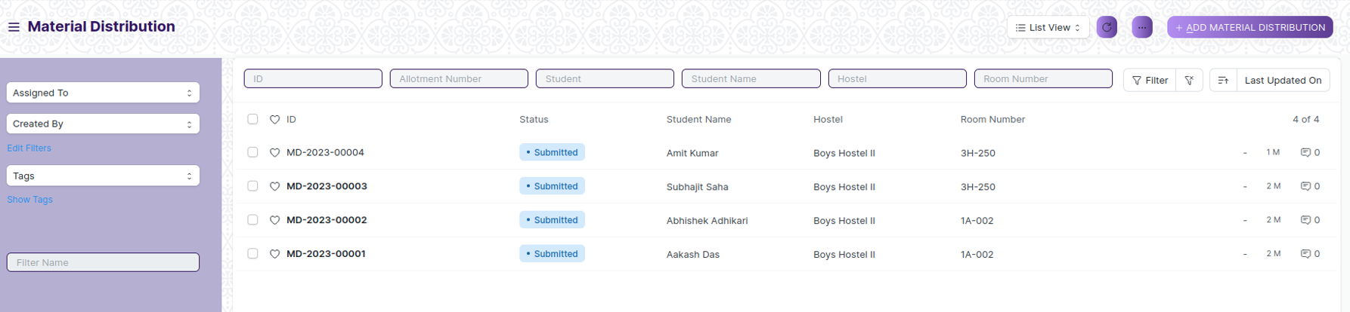

1. Go to Material Distribution list, click on New.
2. Select Allotment Number according to this data all related data will fetch accordingly
3. Materials Allotment table data will fetch from Material Distribution Master form
4. Click on Save and Submit

**View Material Distribution**

As it is a Submit screen, follow the general procedure to view a Submit document as mentioned above .

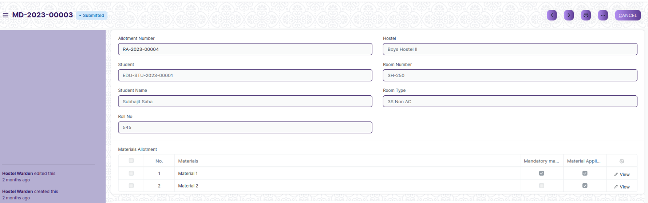

View of a Submit Material Distribution.

**Cancel Material Distribution**

As it is a submittable screen, follow the general procedure to Cancel a submittable document as mentioned above.

**Delete Material Distribution**

If the document is submitted, follow the procedure to delete the submittable document.

**Amend Material Distribution**

As it is a submittable screen , follow the general procedure to Amend the document.

**Edit Material Distribution**

Once the document is submitted , it cannot be edited.

**Print Material Distribution**

Follow the general procedure to print a submit document.

**View Material Distribution Type in different format**

As it is a Submit screen , follow the general procedure to view a submitted document in different format.

## Material Distribution Master

Material Distribution Master is master screen where user is going to maintain Material for distribution.

The screen is accessible to Hostel Warden and Hostel Superintendent,Student.

To access the Material Distribution Master screen ,go to :

***Home>Hostel>Student Admission & Essentials>Material Distribution Master***

Screen Type : Save

**Adding a new Material Distribution Master**

As it is save screen, follow the general procedure to create a save document type as mentioned above.

* Go to Material Distribution Master list, click on New.
* Select Start Date and End Date
* Enter Material Name on the Material distribution Components Table
* Click on Save

After creating a Material Distribution Master, the record will be visible in the List view of the screen.

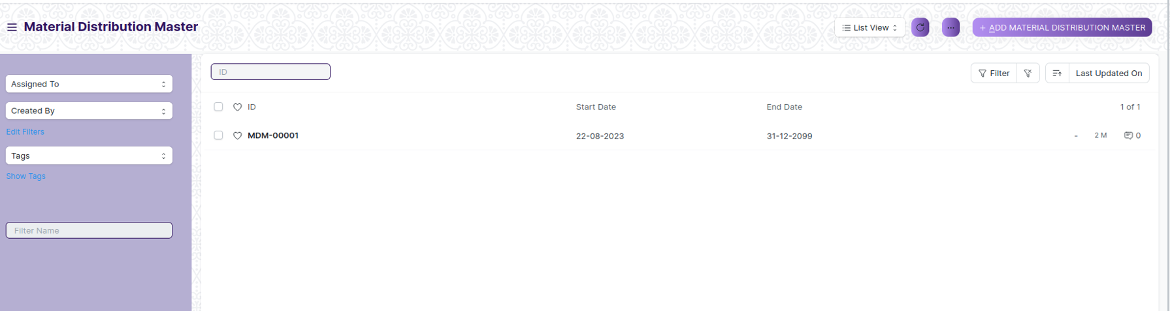

(List View of Material Distribution Master)

**View Material Distribution Master**

As it is a save screen, follow the general procedure to view a save document as mentioned above .

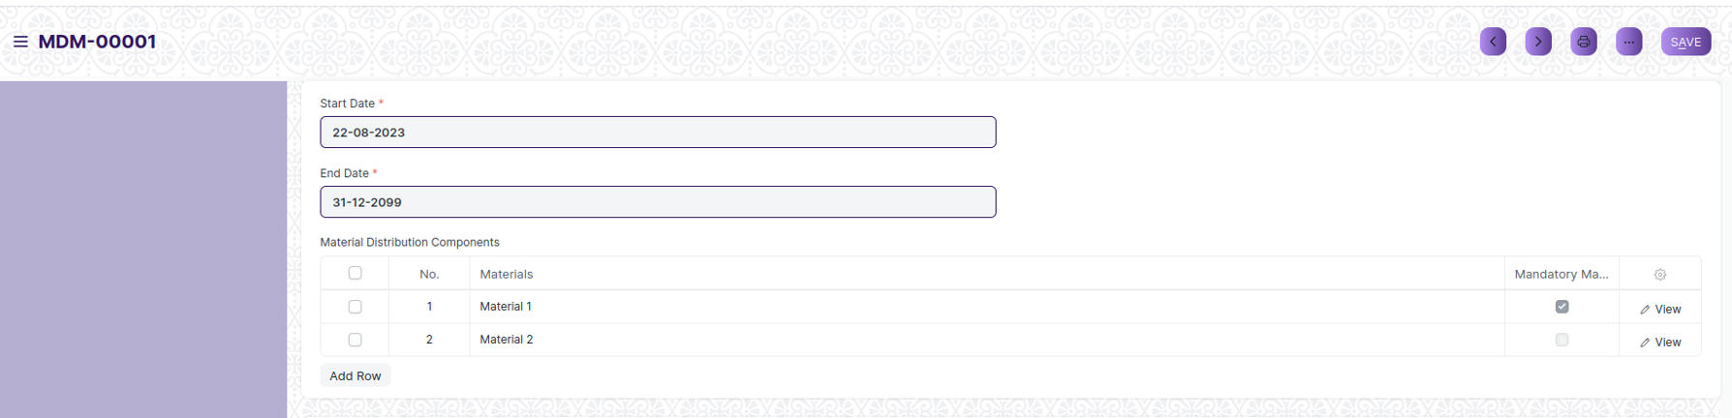

(View of a saved Material Distribution Master.)

**Delete Material Distribution Master**

As it a Save screen , follow the general procedure to delete a save document .

**Edit Material Distribution Master**

Follow the steps to view a saved Material Distributed Master document.

Edit the field that you want to change.

Click on Save.

**Print Material Distribution Master**

As it is a Save screen , follow the general procedure to print a saved document.

**View Material Distribution Master in different format**

As it is a Save screen , follow the general procedure to view a saved document in different format.

## Room Allotment

he Room Allotment is the process where student will get their confirmation for hostel and room.In this Student will get Hostel room what they want in Admission time. If that Hostel room not present then alternative rooms can be assigned.

The screen is accessible to Hostel Warden and Hostel Superintendent.

To access the Room Allotment screen ,go to :

***Home>Hostel>Allotment & De-Allotment>Room Allotment***

Screen Type : Save and Submit

**Prerequisites**

Before creating Room Allotment, it is advisable you create the following documents:

* Student(“Student Hostel Admission” Completed),
* Hostel Masters,
* Room Masters

**Adding a new Room Allotment**

As it is a Submit screen, follow the general procedure to create a Submit document as mentioned above .

After creating Room Allotment, the record will be visible in the List view of the screen.

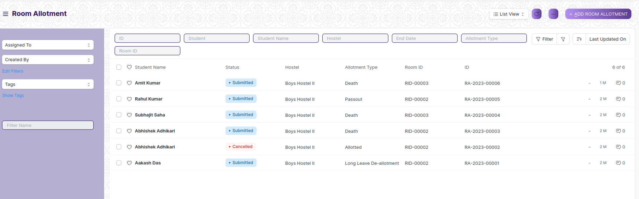

1. Go to Room Allotment list, click on New.
2. Select Student, Hostel and Room Id
3. Click on Save and Submit

**View Room Allotment**

As it is a Submit screen, follow the general procedure to view a Submit document as mentioned above .

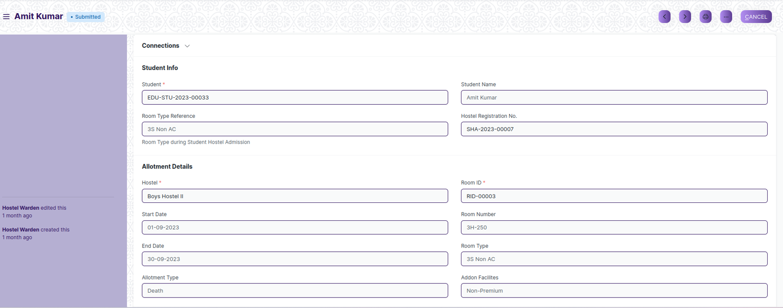

View of a Submit Room Allotment.

**Cancel Room Allotment**

As it is a submittable screen, follow the general procedure to Cancel a submittable document as mentioned above.

**Delete Room Allotment**

If the document is submitted, follow the procedure to delete the submittable document.

**Amend Room Allotment**

As it is a submittable screen , follow the general procedure to Amend the document.

**Edit Room Allotment**

Once the document is submitted , it cannot be edited.

**Print Room Allotment**

Follow the general procedure to print a submit document.

**View Room Allotment Type in different format**

As it is a Submit screen , follow the general procedure to view a submitted document in different format.

## Room De-Allotment

The Room De-Allotment is the process where student are de-alloted from hostel and room.

The screen is accessible to Hostel Warden and Hostel Superintendent.

To access the Room De-Allotment screen ,go to :

***Home>Hostel>Allotment & De-Allotment>Room De-Allotment***

Screen Type : Save and Submit

**Prerequisites**

Before creating Room De-Allotment, it is advisable you create the following documents:

* Room Allotment

**Adding a new Room De-Allotment**

As it is a Submit screen, follow the general procedure to create a Submit document as mentioned above .

After creating Room De-Allotment, the record will be visible in the List view of the screen.

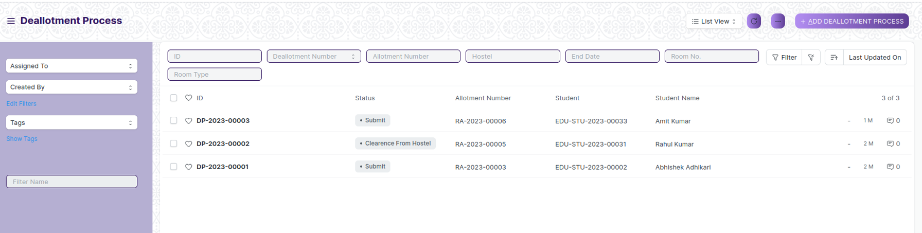

1. Go to Room De-Allotment list, click on New.
2. Select Allotment Number and End Date
3. Upload Attachment
4. Click on Save and Submit
5. After Save, Workflow is started:

Configure the workflow with the following stages:

**Stage 1**: Submit

Description: Initial stage when the Room De-Allotment is created.

Allowed Transitions:Approved

**Stage 2**: Approved

Description: The Room De-Allotment is Approved by Hostel Warden.

Allowed Transitions: Rejected

**Stage 3**: Rejected

Description:The Room De-Allotment is Rejected by Hostel Warden.

**Stage 4**: Withdrawal of Application

Description:The Room De-Allotment form status is changed to Withdrawal of Application by Hostel Warden.

**Stage 5**: Approved

Description: The Room De-Allotment is Approved by Hostel Warden.

Allowed Transitions: Rejected

**Stage 6**: Rejected

Description:The Room De-Allotment is Rejected by Hostel Warden.

**Stage 7**:Clearance From Hostel

Description:The Room De-Allotment form status is changed to Clearance From Hostel by Hostel Warden.

**View Room De-Allotment**

As it is a Submit screen, follow the general procedure to view a Submit document as mentioned above .

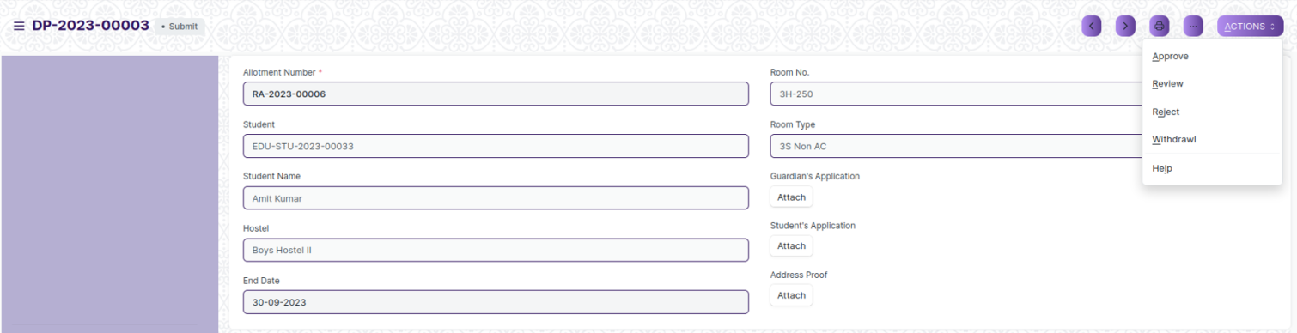

View of a Submit Room Allotment.

**Cancel Room De-Allotment**

As it is a submittable screen, follow the general procedure to Cancel a submittable document as mentioned above.

**Delete Room De-Allotment**

If the document is submitted, follow the procedure to delete the submittable document.

**Amend Room De-Allotment**

As it is a submittable screen , follow the general procedure to Amend the document.

**Edit Room De-Allotment**

Once the document is submitted , it cannot be edited.

**Print Room De-Allotment**

Follow the general procedure to print a submit document.

**View Room De-Allotment Type in different format**

As it is a Submit screen , follow the general procedure to view a submitted document in different format.

## Room Change

The Room Change is the process where student can be transferred from one room to another.

The screen is accessible to Hostel Warden and Hostel Superintendent.

To access the Room Change screen ,go to :

***Home>Hostel>Allotment & De-Allotment>Room Change/Room Type Change***

Screen Type : Save

**Prerequisites**

Before creating an Room Change, it is advisable you create the following documents:

* Room Allotment,
* Hostel Masters,
* Room Masters

**Adding a new Room Change**

As it is save screen, follow the general procedure to create a save document type as mentioned above.

1. Go to Room Change list, click on New.
2. Select Allotment Number, Hostel and Room
3. Write application on Application field or Add Attachment
4. Click on Save
5. After Save, Workflow is started:

Configure the workflow with the following stages:

**Stage 1**: Pending

Description: Initial stage when the Room Change is created.

Allowed Transitions:Approved

**Stage 2**: Approved

Description: The Room Change is Approved by Hostel Warden.

Allowed Transitions: Withdrawal of Application

**Stage 3**:Withdrawal of Application

Description:The Room Change form status is changed to Withdrawal of Application by Hostel Warden.

**Stage 4**: Approved

Description: The Room Change is Approved by Hostel Warden.

Allowed Transitions: Rejected

**Stage 5**: Rejected

Description:The Room Change is Rejected by Hostel Warden.

**Stage 7**:Reported

Description:The Room Change form status is changed to Reported by Hostel Warden.

**Stage 8**:Not-Reported

Description:The Room Change form status is changed to Not-Reported by Hostel Warden.

After creating a Room Change, the record will be visible in the List view of the screen.

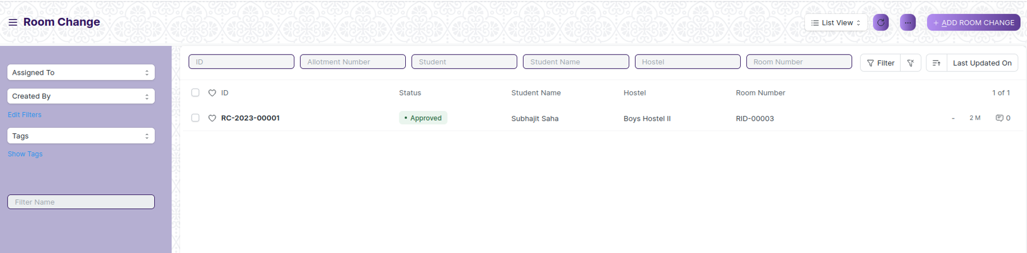

(List View of Room Change)

**View Room Change**

As it is a save screen, follow the general procedure to view a save document as mentioned above .

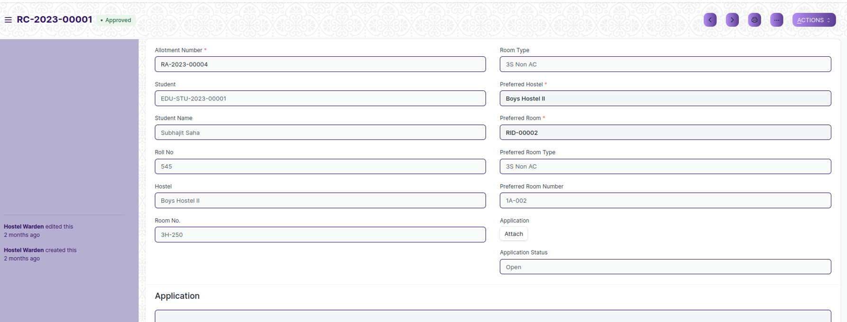

(View of a saved Room Change.)

**Delete Room Change**

As it a Save screen , follow the general procedure to delete a save document .

**Edit Room Change**

Follow the steps to view a saved Room Change document.

Edit the field that you want to change.

Click on Save.

**Print Room Change**

As it is a Save screen , follow the general procedure to print a saved document.

**View Room Change in different format**

As it is a Save screen , follow the general procedure to view a saved document in different format.

## Student Mortality Record

Student Mortality Record is the process where student is de-alloted from hostel after his/her death.

The screen is accessible to Hostel Warden and Hostel Superintendent.

To access the Student Mortality Record screen ,go to :

***Home>Hostel>Student Admission & Essentials>Student Mortality Record***

Screen Type : Save & Submit.

**Prerequisites**

Before creating Student Mortality Record, it is advisable you create the following documents:

* Room Allotment
* Employee

**Adding a new Student Mortality Record**

As it is a Submit screen, follow the general procedure to create a Submit document as mentioned above .

After creating Student Mortality Record, the record will be visible in the List view of the screen.

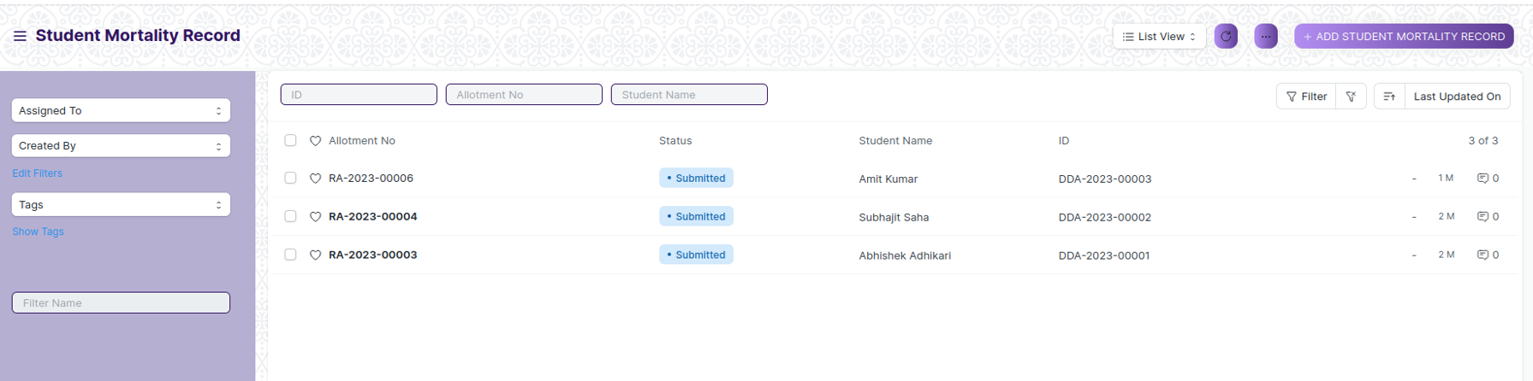

1. Go to Student Mortality Record list, click on New.
2. Select Allotment Number and all important data of Demise like date, reason and more.
3. Click on Save and Submit

**View Student Mortality Record**

As it is a Submit screen, follow the general procedure to view a Submit document as mentioned above .

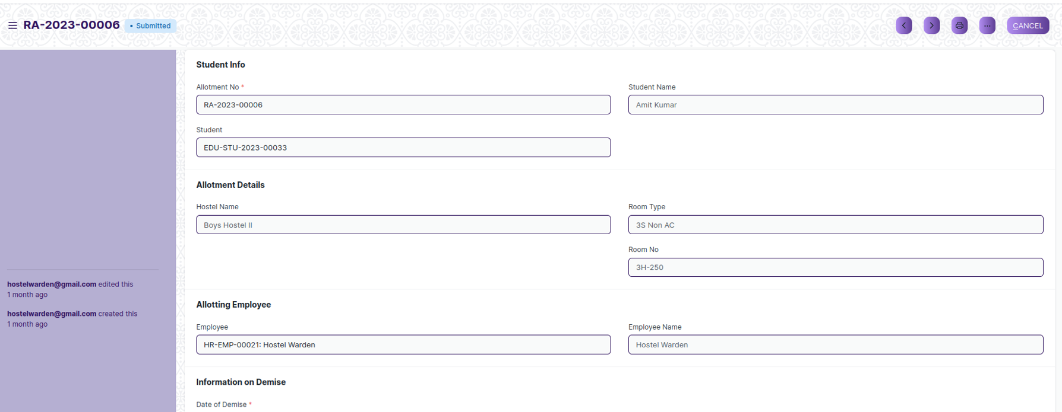

View of a Submit Student Mortality Record.

**Cancel Student Mortality Record**

As it is a submittable screen, follow the general procedure to Cancel a submittable document as mentioned above.

**Delete Student Mortality Record**

If the document is submitted, follow the procedure to delete the submittable document.

**Amend Student Mortality Record**

As it is a submittable screen , follow the general procedure to Amend the document.

**Edit Student Mortality Record**

Once the document is submitted , it cannot be edited.

**Print Student Mortality Record**

Follow the general procedure to print a submit document.

**View Student Mortality Record Type in different format**

As it is a Submit screen , follow the general procedure to view a submitted document in different format.

## Long Leave

A long leave in a hostel typically refers to an extended absence from the hostel, usually for a period of several weeks or months. This may be due to a variety of reasons, such as academic breaks, travel plans, personal reasons, or medical issues.

During a long leave, the hostel resident typically vacates their room or bed and temporarily suspends their membership or agreement with the hostel.

The screen is accessible to Hostel Warden,Student and Hostel Superintendent.

To access the Long Leave screen ,go to :

***Home>Hostel>Allotment & De-Allotment>Long Leave***

Screen Type : Save

**Prerequisites**

Before creating an Long Leave, it is advisable you create the following documents:

* Room Allotment,

**Adding a new Long Leave**

As it is save screen, follow the general procedure to create a save document type as mentioned above.

1. Go to Long Leave list, click on New.
2. Select Allotment number and Start date
3. Select Medium Of Communication and then field will visible. So, enter data accordingly.
4. Select Medium Of Communication from Student and then field will visible. So, enter data accordingly.
5. Click on Save
6. After Save, Workflow is started:

Configure the workflow with the following stages:

**Stage 1**: Notification to Administration

Description: Initial stage when the Long Leave is submitted.

Allowed Transitions: Communication to the student.

**Stage 2**: Communication to Student

Description: The Room Change is Approved by Hostel Warden.

Allowed Transitions: Withdrawal of Application

**Stage 3**: Willing to Report

Description:The Room Change form status is changed to Withdrawal of Application by Hostel Warden.

**Stage 4**: Approved

Description: The Room Change is Approved by Hostel Warden.

Allowed Transitions: Rejected

**Stage 5**: Rejected

Description:The Room Change is Rejected by Hostel Warden.

**Stage 7**: Reported

Description:The Room Change form status is changed to Reported by Hostel Warden.

**Stage 8**: Not-Reported

Description:The Room Change form status is changed to Not-Reported by Hostel Warden.

After creating a Long Leave, the record will be visible in the List view of the screen.

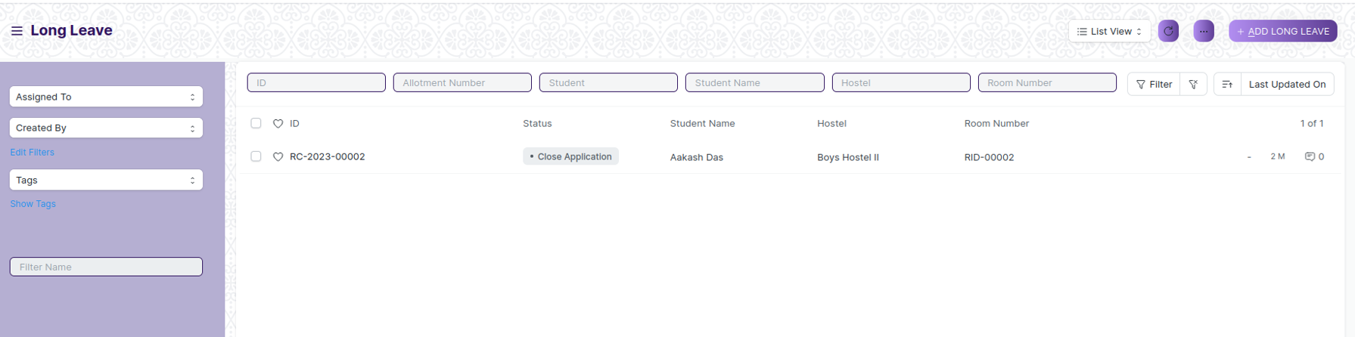

(List View of Long Leave)

**View Long Leave**

As it is a save screen, follow the general procedure to view a save document as mentioned above .

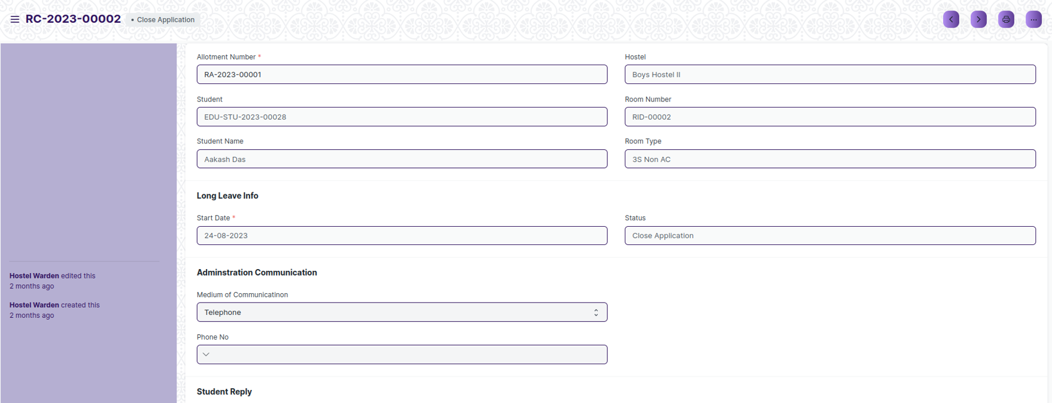

(View of a saved Long Leave.)

**Delete Long Leave**

As it a Save screen , follow the general procedure to delete a save document .

**Edit Long Leave**

Follow the steps to view a saved Long Leave document.

Edit the field that you want to change.

Click on Save.

**Print Long Leave**

As it is a Save screen , follow the general procedure to print a saved document.

**View Long Leave in different format**

As it is a Save screen , follow the general procedure to view a saved document in different format.

## Inter or Intra Hostel Change

An inter-hostel change refers to a situation where a person moves from one hostel to another, where as an intra-hostel change refers to a situation where a person moves from one room to another within the same hostel.

The screen is accessible to Hostel Warden and Hostel Superintendent.

To access the Inter or Intra Hostel Change screen ,go to :

***Home>Hostel>Student Admission & Essentials>Inter or Intra Hostel Change***

Screen Type : Save & Submit.

**Prerequisites**

Before creating Inter or Intra Hostel Change, it is advisable you create the following documents:

* Room Allotment

**Adding a new Inter or Intra Hostel Change**

As it is a Submit screen, follow the general procedure to create a Submit document as mentioned above .

After creating Inter or Intra Hostel Change, the record will be visible in the List view of the screen.

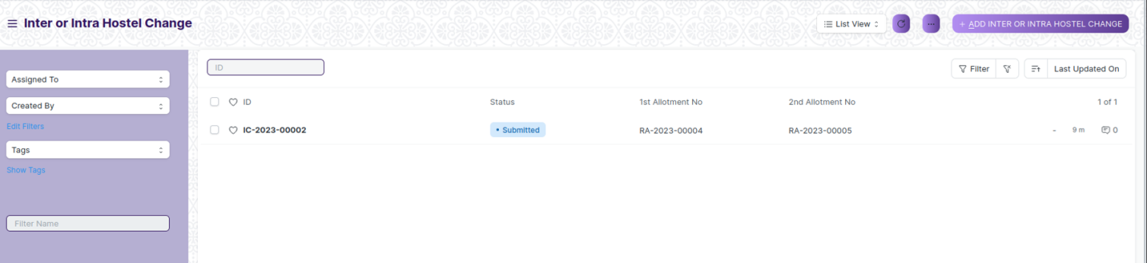

1. Go to Inter or Intra Hostel Change list, click on New.
2. Select 1st Allotment number and 2nd Allotment number
3. Click on Save and Submit

**View Inter or Intra Hostel Change**

As it is a Submit screen, follow the general procedure to view a Submit document as mentioned above .

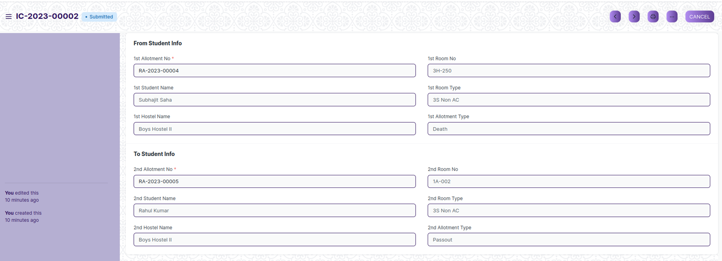

View of a Submit Inter or Intra Hostel Change.

**Cancel Inter or Intra Hostel Change**

As it is a submittable screen, follow the general procedure to Cancel a submittable document as mentioned above.

**Delete Inter or Intra Hostel Change**

If the document is submitted, follow the procedure to delete the submittable document.

**Amend Inter or Intra Hostel Change**

As it is a submittable screen , follow the general procedure to Amend the document.

**Edit Inter or Intra Hostel Change**

Once the document is submitted , it cannot be edited.

**Print Inter or Intra Hostel Change**

Follow the general procedure to print a submit document.

**View Inter or Intra Hostel Change Type in different format**

As it is a Submit screen , follow the general procedure to view a submitted document in different format.

## Hostel Attendance

Hostel Attendance is the process of recording the presence or absence of students who reside in a hostel or dormitory.

The screen is accessible to Hostel Warden,Student and Hostel Superintendent.

To access the Hostel Attendance screen ,go to :

***Home > Hostel > Attendance > Hostel Attendance***

Screen Type : Save & Submit.

**Prerequisites**

Before creating Hostel Attendance, it is advisable you create the following documents:

* Room Allotment

**Adding a new Hostel Attendance**

As it is a Submit screen, follow the general procedure to create a Submit document as mentioned above .

After creating Hostel Attendance, the record will be visible in the List view of the screen.

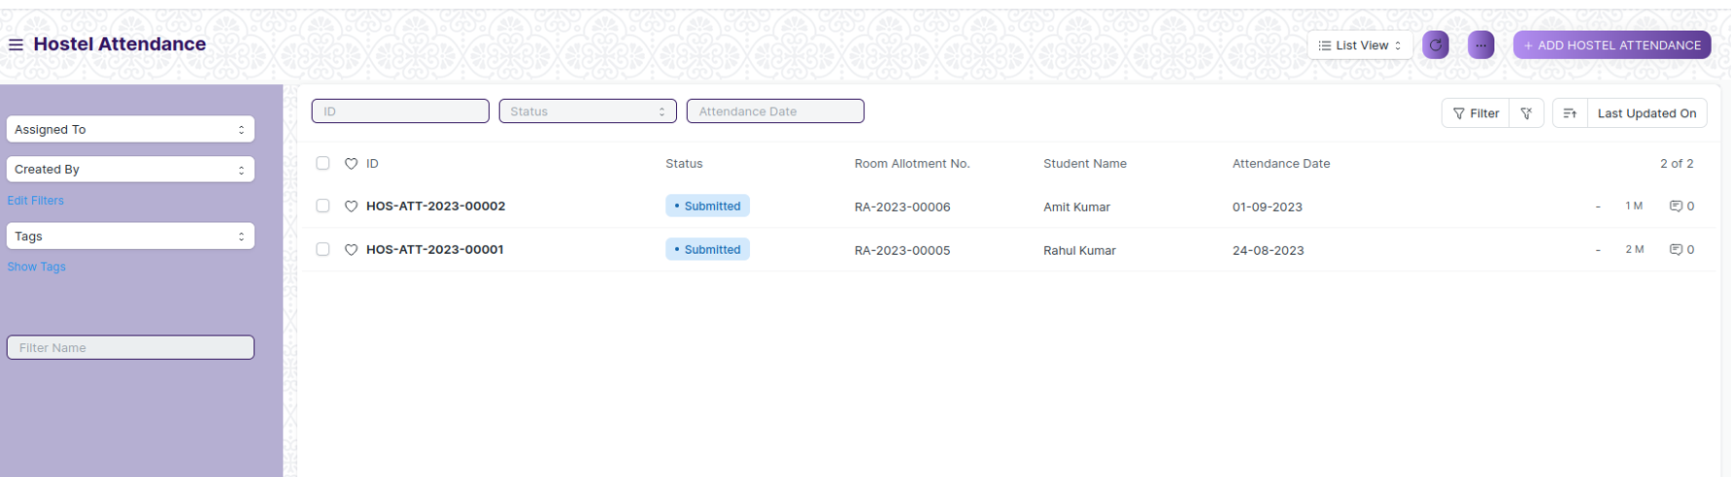

1. Go to Hostel Attendance list, click on New.
2. Select Room Allotment No. and Attendance Date
3. Select Status as “Present” or “Absent” or “On Leave”
4. User can also Maintain Late Entry through Check Box.
5. Click on Save and Submit

**View Hostel Attendance**

As it is a Submit screen, follow the general procedure to view a Submit document as mentioned above .

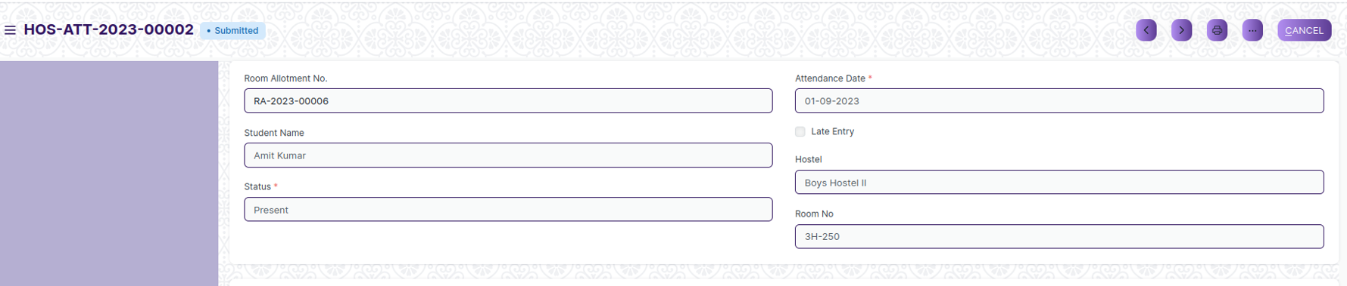

View of a Submit Hostel Attendance.

**Cancel Hostel Attendance**

As it is a submittable screen, follow the general procedure to Cancel a submittable document as mentioned above.

**Delete Hostel Attendance**

If the document is submitted, follow the procedure to delete the submittable document.

**Amend Hostel Attendance**

As it is a submittable screen , follow the general procedure to Amend the document.

**Edit Hostel Attendance**

Once the document is submitted , it cannot be edited.

**Print Hostel Attendance**

Follow the general procedure to print a submit document.

**View Hostel Attendance Type in different format**

As it is a Submit screen , follow the general procedure to view a submitted document in different format.

## Hostel Attendance Tool

Hostel Attendance tool is the process of recording the presence or absence of students who reside in a hostel or dormitory. In this user can take attendance in bulk.

The screen is accessible to Hostel Warden and Hostel Superintendent.

To access the Hostel Attendance Tool screen ,go to :

***Home > Hostel > Attendance > Hostel Attendance Tool***

**Prerequisites**

Before creating Hostel Attendance Tool, it is advisable you create the following documents:

* Room Allotment

**Adding a new Hostel Attendance Tool**

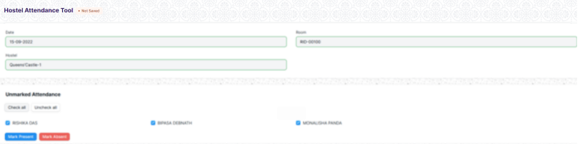

1. Go to Hostel Attendance Tool list, click on New.
2. Select Hostel, Room and Date according to this all student data will fetch below.
3. User will give attendance
4. Click on Marked Present or Absent accordingly.

## Hostel Clearance

Hostel Clearance is the process where student finished his time staying in hostel. In this due fees clearance occur. It may happen by Cancellation of Admission or Academic Pass-out.

The screen is accessible to Hostel Warden and Hostel Superintendent.

To access the Hostel Clearance screen ,go to :

***Home > Hostel > Hostel Clearance> Hostel Clearance***

Screen Type : Save & Submit.

**Prerequisites**

Before creating Hostel Clearance, it is advisable you create the following documents:

* Room Allotment

**Adding a new Hostel Clearance**

As it is a Submit screen, follow the general procedure to create a Submit document as mentioned above .

After creating Hostel Clearance, the record will be visible in the List view of the screen.

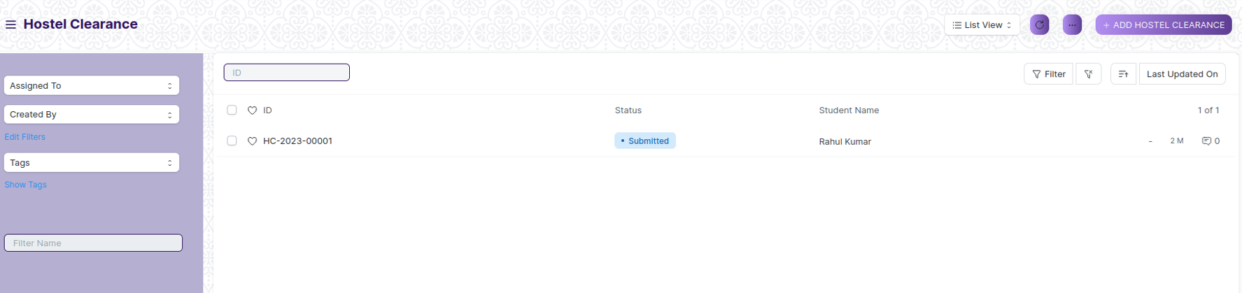

1. Go to Hostel Clearance list, click on New.
2. Select Allotment Number and End date
3. Select Type Of Clearance
4. Select Due Status
5. Click on Save and Submit

**View Hostel Clearance**

As it is a Submit screen, follow the general procedure to view a Submit document as mentioned above .

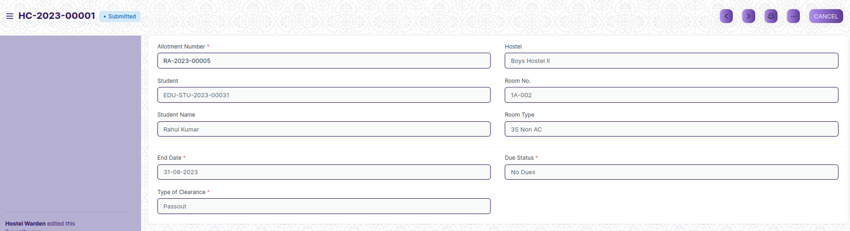

View of a Submit Hostel Clearance.

**Cancel Hostel Clearance**

As it is a submittable screen, follow the general procedure to Cancel a submittable document as mentioned above.

**Delete Hostel Clearance**

If the document is submitted, follow the procedure to delete the submittable document.

**Amend Hostel Clearance**

As it is a submittable screen , follow the general procedure to Amend the document.

**Edit Hostel Clearance**

Once the document is submitted , it cannot be edited.

**Print Hostel Clearance**

Follow the general procedure to print a submit document.

**View Hostel Clearance Type in different format**

As it is a Submit screen, follow the general procedure to view a submitted document in different format.